How organisations can monitor employees

GPS location tracking
A GPS satellite is able to continuously record its location and current time. It can also work out the distance from it to a receiver, a device such as a satnav system inside a car. When three or four satellites record this information they are able to pinpoint exactly where the receiver is by calculating the amount of time it takes for the signals to reach the receiver.

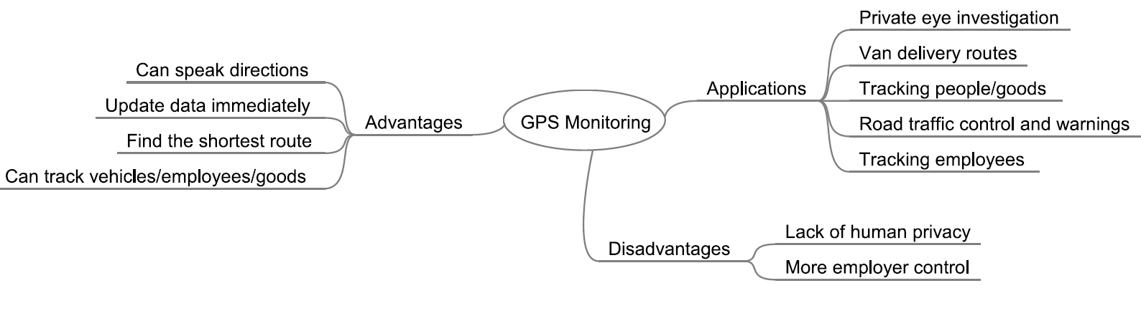

Monitoring Internet use
Popular methods of monitoring Internet use include: installing appropriate software on a system that logs usage; setting the operating system; or looking at the web browser history.

Monitoring communications
It is possible to install mobile phone surveillance programs which allow the installer to read emails.

