Storage and connectivity devices
Business organisations have to consider the storage requirements of the systems they use. Not only do they consider the system memory available in which to store operating systems and application software, they must also consider external storage in terms of extra memory, security and employee accessibility.

Storage devices fit into several categories depending on the method that is used to store the data.

Optical disks
An optical disk looks very similar to a normal audio compact disk. Two popular types are Compact Disks (CDs) and Digital Versatile Disks (DVDs). There are many versions available in the modern market such as CD-R, CD-R/W, DVD-R/W and DVD-R. In terms of these extensions R means ‘read only’. Once the data is written to the disk it can be read as many times as necessary. The data on the disk, however, cannot be changed. This is known as WORM – write once, read many. R/W means the disk can be written to many times.

Compact Disc (CD)
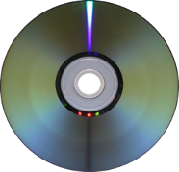
A CD can store up to 650 MB of data in digital format on a single surface. This is done by using a red laser which burns the data onto the disk. Because data is burnt onto the CD this makes it more robust than many other magnetic media. It is quite cheap to purchase and its low weight, ease of packaging and portability make it an ideal medium for businesses to distribute software, audio and pictures. It is also a direct access medium which means that the data can be found quickly.

Digital Versatile Disc (DVD)
A DVD is read and written to the optical disk using a laser beam at speeds of approximately 150 KB per second. The DVD stores the data in two layers using a blue laser beam and this has the effect of doubling the amount of data that it can store. An average DVD can hold 17 GB of data. This makes it a more suitable medium for the distribution of high-definition video, pictures and sound.

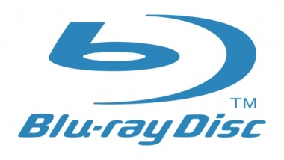
Blu-Ray Disc (BD)
Blu-ray disks hold up to 25GB of data (single layer) or 50GB (dual layer). Used to store high definition video content, and video games, e.g. for Playstation 3.
Like CD/DVD drives, Blu-Ray -readable drives are a standard component of modern computers. However, at the time of writing this, if you want to write data to a Blu-Ray disc, a special (and expensive) drive is needed.

Magnetic media
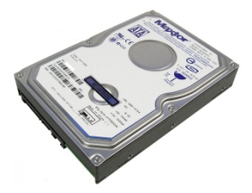
These tend to be hard disks which are inside the computer system, portable hard disks which are external to the computer system and magnetic tape.

Internal hard disk and external hard disk
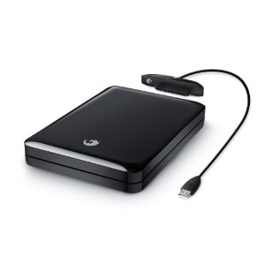
Both of these storage devices can hold up to approximately 1.2 TB of data. Retrieval is fast because they are random access media and can transfer about 40 MB of data per second using hard disk drives (HDD).

The internal hard disk is contained inside the casing of the computer and the external hard drive is a separate, portable device. This form of storage is quite expensive compared to other forms of storage and, in the case of the internal hard drive, can slow the processing down if it gets too full.

Users tend to store the programs they are working on or have recently worked on in the internal hard drive while the external hard drive tends to be used as a backup medium. The internal hard drive tends to come with the computer system and, if required, the external hard disk is an added extra cost.

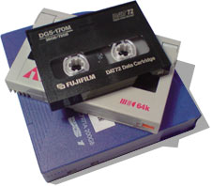
Magnetic tape
Magnetic tape comes in the form of a tape cartridge. Special software is required to read the data to and from the tape as the data stored on the tape is very densely stored. This is a very cheap method of storing data compared to other storage methods as a lot of data can be stored on the cartridge. However, it is slow to read to and from and therefore, as it is good for business organisation backup, it tends to be carried out at night when the system is not in use. This does not affect the business as this can be done automatically by the computer system without any human intervention.

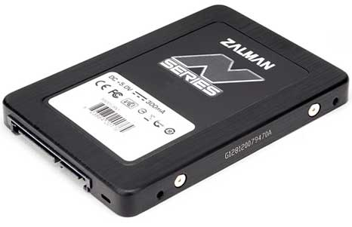
Solid State Drives
Solid-state refers to storage technology that does not have any moving mechanical parts. This differs from traditional magnetic storage such as hard disk drives, which are electromechanical devices containing spinning disks and movable read/write heads.

Advantages include better performance in terms of reduced failure rate and faster read/write speed. They are also silent, with no vibration, both due to lack of any moving parts. However they are currently more expensive than magnetic hard drives, and are currently only available at smaller storage capacities.

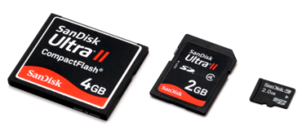
Memory cards
Flash based media such as memory cards are solid state in nature as they contain no moving parts. They come in many forms, such as pens or cards.

Memory pens are popular because they are very small, lightweight and portable. Their capacity (up to 5 GB) makes them an ideal personal storage medium for transferring data. Businesses such as Internet providers find them useful for assisting consumers to log their portable devices on to the Internet.

Memory cards, on the other hand, are more easily damaged than a pen. Although they hold less data than a pen (approximately 8 GB), they are useful as storage devices inside small portable devices such as digital cameras and mobile phones. They, too, are portable and cards can be inserted into different devices.

Network devices
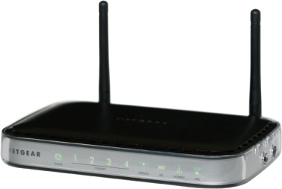
The main network devices are routers and modems, although there are others.

A router is a device that transfers data between two different networks. It finds the best route possible to send this data. If a business is trying to transfer data between networks of two different types or through the Internet (which is made up of differing systems), it requires a router. Routers can be either wired or wireless. Wireless is very popular with home computing, especially in homes where there are several computer systems (for example a portable computer, a netbook and a stand-alone device) trying to connect to the Internet. The router is connected to the main telephone cable coming into the house and the other computer systems can then be situated in different places around the home without the need for cables.

A modem transfers data from analogue to digital and vice versa. A computer works in digital form. When it wants to connect to the Internet it usually does so through analogue cables. A modem connected to the computer system is required to carry out this conversion. It also reverses the data coming from the Internet from analogue to digital back into the computer system. If a business wishes to have Internet access, even if only for email purposes, then it requires the computer system to have access to a modem, either an internal or external one.
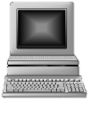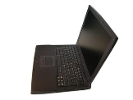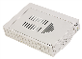Cloud storage

This is a method of storage in which a remote computer is used to store and process data. The user’s computer only holds the data while it is being used. The data is actually held on a ‘cloud’. The user does not, therefore, need a powerful or even large computer, a mobile phone will do. When necessary, they request the data they need from the higher powered computers which hold the data. These computers can be anywhere in the world. An example of cloud storage is iCloud, a service provided by Apple.

Cloud storage is useful for businesses as it reduces the need to purchase computers and storage. Instead, storage is treated as a utility service –the business pays another company to provide the storage and to deliver the data as and when needed. The main concern, however, is that of security. The business has no control over where their data stored.

