Output devices
It is no good putting data into a system if the business cannot get the information out in the format they require.

Printer
The main feature of a printer is that it produces hard copy. This hard copy can be given to others to read, can be signed by hand, can be copied and can be scanned into a computer system for future reference. With the advent of the Internet and online shopping the printer tends not to be as popular as it was. However, it still has a place and is still an important peripheral in businesses. The speed is measured in how many pages per minute (ppm) a printer can produce.

Several types exist:

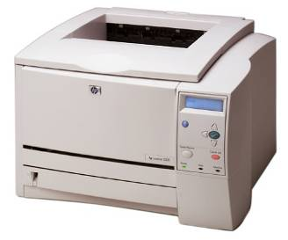
Laser
A laser printer has a drum containing dust. When a printout is required the print image is magnetised and dust is drawn to the paper in the pattern of the image. This pattern of dust is then burnt into the paper in order for it to hold the pattern. A laser printer can be connected by wires or wirelessly to a stand-alone computer as a resource in a network. Modern laser printers can also be used as fax machines.

A laser printer can be quite expensive. They come in A3 and A4 size and the drums can hold coloured dust (more expensive than black) if colour printing is required. The image (text and/or graphics) is coated with the toner. Paper is pressed against this image and heated to melt the toner into the paper. The quality of this output is very good. Laser printers are fast and quiet which are benefits in busy office environments where both the level of noise and speed are important factors.

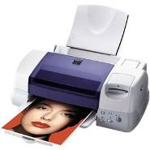
Inkjet
An inkjet printer works by squirting tiny jets of coloured ink onto a page. It uses a combination of four colours. The image is built up using these varying dots of colour.

This type of printer is cheaper to purchase than a laser printer but it has very expensive running costs. Ink cartridges are expensive and do not last very long. Of course, it depends how often you use the printer and how much colour printing is on each page as to how long the cartridges will last.

Inkjet printers produce good quality printouts, although not as high quality as laser printers. As the printer has to squirt tiny dots of ink onto the page the process is slow and, therefore, is not suitable in a business environment. However, they are extremely useful for producing one-off colour prints.

Plotter
This output device produces diagrams by dotting pens on paper. Two types of plotter are available: a flatbed and a drum plotter. With the flatbed the paper stays still and a variety of pens dot the image on the paper. With the drum plotter the paper moves and the pens only move with horizontal motion back and forward across the page.

Plotters are very slow to print but can produce very large diagrams which makes them suitable for an architect’s office, kitchen designer or any organisation which has to produce large diagrams.

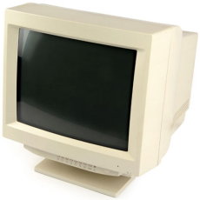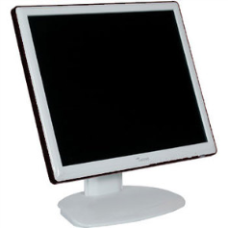Monitor
A monitor, also called a visual display unit (VDU), displays graphics, text and video on a screen. The actual picture is displayed as thousands of coloured dots called pixels. The quality of the picture depends on the number of pixels horizontally and vertically on the screen. This is known as the resolution. The higher the resolution is, the better the quality of the picture.

Two main types of monitor exist. The older type is the CRT (Cathode Ray Tube) monitor. Although they produce the highest quality output, use of CRT monitors has decreased rapidly since TFT (Thin Film Transistor) screens were introduced.
TFT are a type of LCD (Liquid Crystal Display) which provide greater picture quality. They are popular because they take up less desk space, and are lightweight even at large sizes.

Speakers
A speaker produces audio output provided the computer system has a sound card installed. Sound can be output on a computer through either headphones or speakers. Businesses tend to use audio output in automated telephone answering systems as it saves them having to employ a telephone receptionist for dealing with typical responses. Audio output is also useful for alarm systems in an organisation.

Speakers are also used to communicate publically with employees and customers in different industries, including retail supermarkets, railway stations and airports.

Head/earphones
These are personalised speakers in which the user wears a headset containing earphones. No one else can hear what the user is hearing. Because they are worn on the head, the user’s hands are free. This is handy for organisations that employ drivers. Employees that work in call centres and wish to cut out the noise of other employees talking can use headphones. Similarly, headphones can be used for entertainment, e.g. for listening to music.

Digital projector
The modern data projector is connected to a computer system and projects material on the computer screen onto a large whiteboard. In business this is used to enhance group discussion and aid presentations. The whiteboard can be interactive, meaning that the screen can accept input as well as output. Data projectors enhance conferences and presentations as the size of the projected screen improves clarity of materials and allows for staff participation.
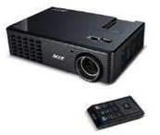

Data projector
An ordinary data projector is an output device that projects material onto a large screen but is not interactive. This is cheaper than a digital projector and is popular for projecting video or displays in conferences or on bulletin boards.

