Networks Mark Scheme
1 Physical configuration/layout [1] of how a network is connected/linked together [1] #

2 Must identify the issue and expand on it.
- size of organisation [1]
  - Needs can range from a small LAN to a global WAN.
  - Some communications media are limited to the distance they have to travel.
  - Amount of data processing required must also be considered.

- how the system will be used [1]
  - What type of applications do users require?/ Are the users going to require a wide range of applications?
  - Will they need large data storage?
  - From where will they operate the network e.g. at home in office or remote access from different locations.

- existing systems [1]
  - More often networks are not developed from scratch but need to fit in with existing systems. Sometimes an extension is required e.g. when a new branch office opens.
  - Therefore any new network must fit in with the existing operating systems and protocols.
  - It must support any peripherals already in use e.g. bar code readers, printers, OS etc.

- performance required [1]
  - Different parts of the organisation may have different performance requirements, e.g a real time e-commerce system may require greater speeds and capacity and security than the in-house payroll system
  - A system for a school may have different requirements that a system needed for a group of ICT technicians

3
4 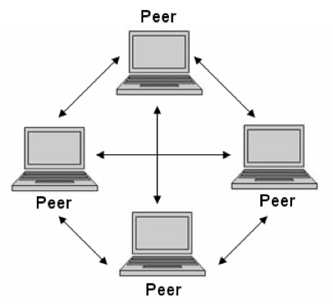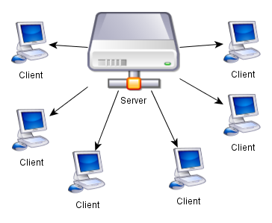

5
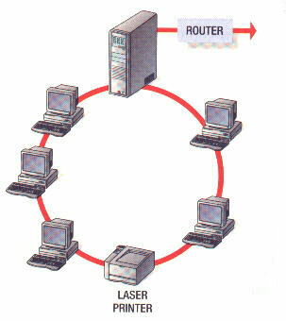
Advantages of ring
- Network not dependant on central computer
- Each computer has the same access as the others so no one computer can hog the network
Disadvantages of ring
- If there is a break in the connection then the whole network fails
- Faults are difficult to locate
- It is impossible to keep the network running whilst equipment is added or removed
- because there is only one path for the data to follow

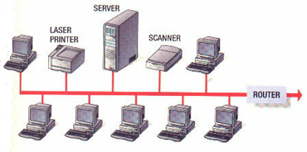
Advantages
- Easy to install
- Easy to add extra workstations
- Uses less cable than a Star network
- Best choice for temporary networks
Disadvantages
- If there is a problem with the central cable/backbone, the entire network stops working
- If there are a lot of workstations on the network, data can travel slowly.
- Data collisions can happen as the network becomes busy
- Low security - every workstation can see all of the data in the network

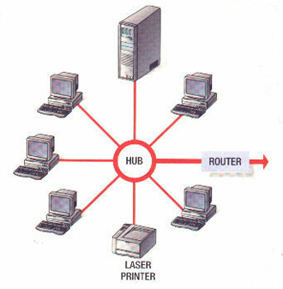
Advantages of star
- Fault tolerant – if one of the cables fails, then the other computers can still be used
- Load tolerant – extra computers can be added without much loss in performance because all computers have their own path to the server
- Easy to add extra computers – extra computers can be added without disturbing the
Disadvantages of star
- Higher cost – the large amount of cabling needed makes it more expensive
- Dependence on the central server

6
Advantages
- allows inexpensive LANs to be set up without cables
- allows people the freedom of working anywhere a signal can be received
- ideal for networks in old listed buildings where cables would not be allowed to be installed
- global set of standards – you can use Wi-Fi all over the world
- can use a variety of devices such as tablets, mobile phones, etc
- health and safety – tidier desktop with no trailing cables.
Disadvantages
- power consumption is high – which means laptops soon exhaust their rechargeable batteries
- there may be health problems in using Wi-Fi
- there may be security problems even when encryption is used
- Wi-Fi networks have a very limited range (e.g. 150 ft)
- can get interference if wireless network signals start to overlap
- transmission speed slower than cable.

