How businesses communicate with employees and others working remotely
All businesses have to communicate. The following are some of the most popular methods that can benefit a business provided they are appropriately used.

Appropriate use of remote communication tools

Voice telephones
This is the standard method of audio communication with much of the world having appropriate telephone cables. However, there are still many areas of the world (e.g. remote areas) in which standard telephone cables do not exist. This is due to the high cost of laying the cables. Furthermore, businesses have to aware that country-to-country telephone communication (when it does exist) can be very expensive, especially if the calls are lengthy.

On the other hand, there is immediate feedback provided the receiver answers the telephone. A previous disadvantage of telephone communication, that users cannot see each other, has been addressed with modern technology in that a video calls can now be made.

SMS
With the advent of the mobile phone, which went some way to address the problem of lack of communication cables, so too came SMS (short message service). The majority of people now have mobile phones and many businesses even provide mobile phones for business use. Using SMS is cheaper than phoning. The user needs to be fairly proficient at typing and aware of texting netiquette for it to be a valuable method of communication. However, predictive text is now an added feature. In terms of a business perspective SMS can allow the:
• Sending of a message to many employees at once
• Identification of an employee as it has a sender ID
• Recording what has been sent

Examples of how a business can use SMS:
• Informing customers of a new product launch
• Sending short notes to thank customers for their custom
• Asking customers to fill in short satisfaction surveys
• Reminding staff and customers of appointments
• Advertising and promotion gimmicks such as a free cup of coffee
• Sending alerts. e.g. if a flight or appointment has been delayed
Communication is key in the development of India’s technology. Data is sent by the government and,
as necessary, collected by the receiver. One such system is M4G (Mobile for Good) which uses mobile phone technology. It is a system that allows you to subscribe to receive job listings and health information. People type the job they are looking for on a mobile phone followed by ‘On’ to receive SMS announcements of vacancies. Charging is carried out according to the number of SMS messages received. HIV/AIDS information, breast cancer, diabetes and diet information can also be sent to the population in the same way.

Instant messaging
Instant messaging is a popular method of communication. Messages are sent in real-time and responses are instantaneous. Instant messaging allows many people to participate in a conversation at the same time, without running up a large telephone bill. As well as text, files such as documents and pictures can also be included in instant messages.

Other benefits include:
• Employees can be in various worldwide locations
• Employees can get information from another employee while on the phone with someone else
• Employees can see who is logged on at the same time as them
• They can see what another person’s current status is, e.g. away from desk

Two disadvantages are that emotions and meaning cannot be expressed as well as they can when having face-to-face or telephone conversations and viruses can be spread through files that are shared.

Email
Probably one of the most popular forms of business communication at the moment is email. Email communication can be external or internal. Internal is restricted to communication within a firm and is therefore more secure. External means communication can take place with anyone outside the firm, provided the parties communicating have the appropriate hardware and software.

Below are just some of the features which make email perfect as a business application:
• A message can be sent anywhere in the world at any time
• Attachments, such as documents or zip files can be sent
• Multiple emails can be sent at the same time
• Messages can be hidden from other receivers
• Email messages are free to send

Chat room
A business can set up a private chat room for communication instead of holding a meeting. This is carried out through the Internet and the business can specify which members/employees can get access to the chat room. It is also possible to post pictures but it is possibly less secure.

Forums
A forum is an Internet-based communication method. A community can be created on the forum for people with shared interests. Posts can be posted at any time for permitted viewers of the forum to participate in.

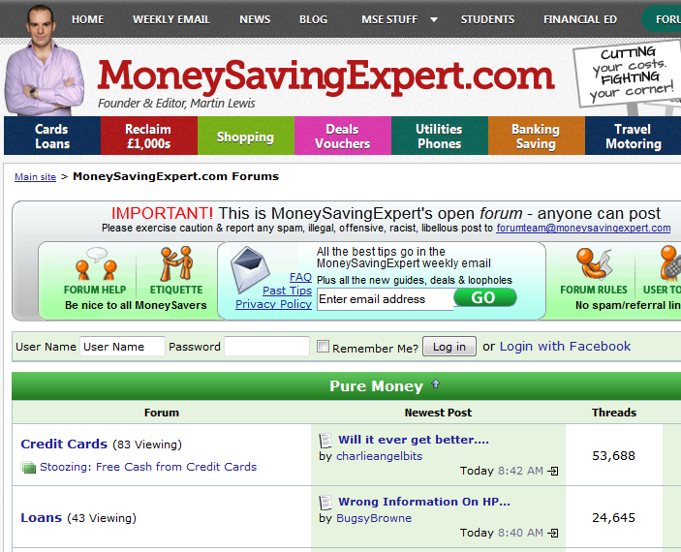
Communication only takes place at the convenience of the individuals involved. If necessary, permission within the forum can be altered by the creator to allow some to read and others to alter the materials.

Popular uses within the business environment are:
• Marketing – offer forum members special discounts on products in return for information
• Allowing interaction to discuss business products or ideas
• Discuss troubleshooting of a product where the forum can be managed by a professional in the field of the problem

Bulletin boards
This is system software that allows users to read news and bulletins, exchange messages or use chat rooms and upload and download software. It can be internal, e.g. a company’s intranet, or external, on the Internet. Messages are left on boards for others to read.

Popular uses within the business environment include:
• A platform to develop ideas
• A platform to publish company news
• A motivational board where company/employee goals can be displayed
• A way of enhancing employee knowledge by displaying customer profiles
• A health and safety notice board, e.g. giving tips on avoiding stress

Voice over Internet Protocol (VoIP)
This is the technology for the delivery of voice communications over IP networks such as the Internet or other packet-switched networks. This is popular with any business that has automated answer phone systems that are capable of redirecting incoming calls to the right people or right section. With regard to call centre businesses this eliminates the need to employ people for this task and thus reduces costs. Other businesses, such as electricity services, allow customers to enter metre readings using VoIP. It is less expensive than videoconferencing, means employees can do business anywhere, allows the use of three-way calls and the recording features mean podcasts can be made of the communications to assist with training staff. One of the most popular examples of this at present is Skype.

Derbyshire Fire and Rescue makes extensive use of information and communications technology (ICT) to support its service delivery, with all its departments and 31 fire stations connected to a WAN for data sharing and the delivery of applications such as a management information system (MIS), which provides incident reporting and performance analysis.

The service also uses VoIP links for communication between major sites. When a fire officer arrives at a remote station, he/she can log in from anywhere in the building without having to track down a spare network cable. Employees are able to ‘hot desk’.

The service is currently looking into an automated system for loading new maps and map-based data onto fire appliances. Automating the updates will provide fire and rescue teams with greater insight into emergency situations and improve civilian safety. New maps can be pushed out whenever there is a change to the database, rather than at quarterly intervals as currently dictated by manpower considerations.

Also a communications system will enable ambulance teams to diagnose and begin treating critically ill patients before they reach hospital. A new communications system between a moving ambulance and its hospital base allows the simultaneous transmission of bandwidth-hungry video and ultrasonic images, telephone communications and patient data, all at the same time.

Putting a ‘virtual doctor’ in ambulance medical teams means that vital and detailed information about the patient’s condition can be gathered and the ambulance team can seek advice on patient treatment as they rush towards the hospital.

Videoconferencing
This is a method of conferencing that uses more than one computer system and in which each person on the system can see and talk to the other person. The initial set-up for this system is expensive as it involves audio and video, which require a high bandwidth, and the appropriate hardware and software. However, if set up correctly it can save a business time, travel, energy and money, and participants can see each other as well as talk to each other.

Popular uses within the business environment:
• Allows multinational companies to hold meetings with employees in different locations
• Using home webcams assists with teleworking
• Can transfer informative presentations if required
• Assists with the on-site training of employees
• Allows for a product demonstration from outside the business
• Enables off-site interaction with employees
• Enables the conducting of off-site interviews

Webcams
This section refers to the uses of a webcam not including videoconferencing. Normally a webcam is attached to the top of a computer monitor but it can also be placed strategically within an organisation to act as a security camera.

Popular uses within the business environment include:
• Employees can see each other as well as speak
• Employers can monitor an employee at work
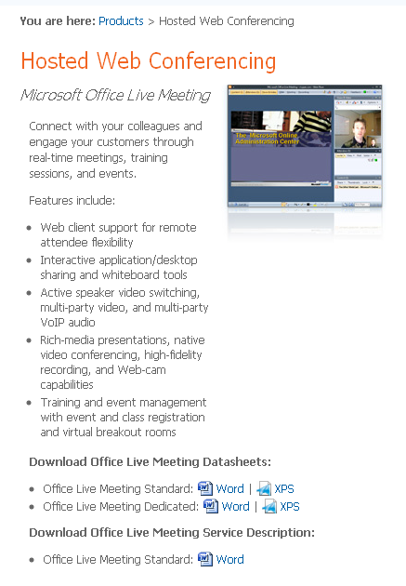
• Employers can monitor the status of projects without leaving their office
• Monitoring when an employee leaves a computer system
• Recording an employee working to use as a training video
• Webcams can be used at trade shows to take pictures of potential customer details which can then be turned into text and stored in address books for future contact
• Can be used as a security surveillance camera
• The encouragement of teleworking

Blogs
A blog is a personal diary or journal of activities or news that is published on the Internet. It is easier for a business to update than having a website presence and the blog is publically available.

Popular uses within the business environment include:
• Share ideas with interested parties and receive feedback
• Can directly market to a target audience, e.g. readers can receive information on a regular basis instead of a newsletter
• Can encourage marketing interest by advertising incentives such as free samples
• Can share solutions
• Can connect a request with the appropriate expertise

Social networking websites
Social networking websites assist the building of social relations among people who, for example, share interests, activities, backgrounds, or real-life connections. Two popular social networking websites include Facebook and Google Plus, which both gives users different ways to communicate such as posting messages, pictures and videos. Each user has their own profile and can communicate with people they know by adding them as ‘friends’. These friends can be categorised into different groups, for example friends, family, co-workers, etc.

LinkedIn is a social networking site. Much like Facebook, LinkedIn allows members to connect with other users on the network, although LinkedIn is geared more toward professional connections.

Popular uses within the business environment include:
• Helps to build a sense of community among employees
• Low-cost way to advertise to millions globally
• Allows recruiters to screen candidates through information found on these sites
• Can market – by getting advertising space they can they offer prizes
• Allows valuable information to be distributed in an inexpensive way, e.g. health information

The benefits and drawbacks of these methods
The benefits and drawbacks of these methods have been discussed in the individual sections above.
It is up to a business to determine what its objectives are and choose the appropriate method of communication. The following criteria must be taken into account:
• The speed of communication
• The security of the communication method
• The hardware and software required
• The privacy of the data
• The amount of information to be communicated
• The type of information to be communicated
• The number of people who have to receive the information
• The impact that the information needs to have

