|  |
| --- |
| OCR Level 1/2 Cambridge Nationals in ICT  **Learner Companion** |
| R001: Understanding Computer Systems |
|  |



**POD 4764**

ICT | LEVEL 1/2 | OCR | CAMBRIDGE NATIONALS

**ict@zigzageducation.co.uk**

**zigzageducation.co.uk**





ZigZag is a large community of over 6000 teachers & educationalists.

Review new titles or publish your own work

Fancy being involved?

Then register at…

publishmenow.co.uk

The Professional Publishing Community

Alternatively email new resource ideas directly to…

publishmenow@zigzageducation.co.uk

**Contents**

[LO1 Understand how ICT can be used to meet business needs 2](#_Toc336874175)

[Features and purposes of computing devices 2](#_Toc336874176)

[Factors affecting the choice of ICT system 17](#_Toc336874177)

[Connecting peripherals to computer devices 18](#_Toc336874178)

[Connecting a computing device to a wireless network 19](#_Toc336874179)

[How organisations can monitor employees 20](#_Toc336874180)

[LO2 Know how to work with information and data to meet specified business needs 22](#_Toc336874181)

[Data capture methods 22](#_Toc336874182)

[Factors affecting the choice of data collection method 25](#_Toc336874183)

[How to design data capture forms to obtain specified information 27](#_Toc336874184)

[Coding information for use in a spreadsheet or database 27](#_Toc336874185)

[Data validation methods 29](#_Toc336874186)

[File formats for storing data 30](#_Toc336874187)

[Data storage technologies 31](#_Toc336874188)

[Security measures to be used when storing data 33](#_Toc336874189)

[Data transferring technologies 36](#_Toc336874190)

[Factors affecting data transfer speed 38](#_Toc336874191)

[Factors affecting the optimisation of electronic files 38](#_Toc336874192)

[Backup and recovery systems 39](#_Toc336874193)

[Factors affecting the choice of backup method 40](#_Toc336874194)

[LO3 How ICT can be used to support business working practices 41](#_Toc336874195)

[How businesses communicate with employees and others working remotely 41](#_Toc336874196)

[How diary management software can be used to organise work schedules 46](#_Toc336874197)

[How documents can be created and edited collaboratively 47](#_Toc336874198)

[LO4 Legal, ethical, safety and security issues when using ICT 49](#_Toc336874199)

[How legislation affects business computer users 49](#_Toc336874200)

[How moral and ethical issues affect business computer users 51](#_Toc336874201)

[Implications and consequences for organisations of data loss, corruption and theft 52](#_Toc336874202)

[The main threats to data security 54](#_Toc336874203)

[Automatic and manual updates for operating systems and security software 56](#_Toc336874204)

[Practice Scenarios 57](#_Toc336874206)

y

# LO1 Understand how ICT can be used to meet business needs

## Features and purposes of computing devices

### 45383326Desktop and portable devices

Much has changed over the last few years in the ways that businesses operate. Long gone are the days in which it was a necessity to go to the office. Trends are such that businesses can now be run from home (teleworking) or indeed from any location. Some businesses do not even have a base, either home or work; in fact, they are mobile. Technology has assisted in such business needs through the use of both desktop and portable computers.

These computers have specific features which lend themselves to these various needs.

#### Desktop computers

Traditionally this is described as a stand-alone computer system which sits on a work desk, although it may be part of a network. This type of computer system is suitable for an office system as it tends to have lots of working memory (RAM) and powerful processors. At the time of writing 600 GB is a typical computer storage capacity and 4GB RAM is a common memory size. Central Processing Units (CPU) are now multi-core (e.g. dual / quad), which allow vast amounts of data to be processed simultaneously.

The user tends to use a keyboard and a mouse to enter data. Data can be saved externally using CDs, DVDs and removable media such as memory cards and sticks. These systems also tend to have powerful graphics cards which are suitable for a business dealing with a lot of graphics. The lack of portability means that desktops are a more secure option for a business. The business can physically restrict access to the system, can easily secure them to workstations, and also has more control over internal data security within the system by administering passwords, etc.

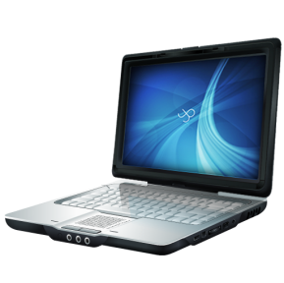

#### Laptops

The reduced size and weight means employees can carry laptops around with them.

Laptops can use the same software as desktop computers, and are able to harness the   
same power as high-end desktop computers – although at a much higher cost than their   
desktop equivalents. An average laptop will have the same technical specification of   
a mid-range desktop computer, i.e. a 500GB hard drive and a multi-core processor.

Laptops have wireless interface cards built-in which facilitates Internet connectivity, allowing employee can send/receive files or communicate while on the move. Battery life is a restriction, although these systems can also use mains electricity. The portable nature of laptops means that they are more easily broken and stolen than desktop computers, therefore data stored on them is less secure.

#### Netbooks

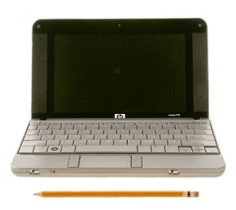Netbooks share features with laptops; they have a small, flat screen display, a touch pad, a battery and a keyboard. However, it is smaller, lighter and has much less processing power than a laptop. The lack of an internal CD/DVD drive, less connections, smaller battery and smaller display contribute to the netbook being small, lightweight, power-efficient and more affordable. They also tend to have smaller hard drives and less powerful CPUs (at the time of writing, a typical netbook hard drive was around 300GB, with either a single or dual-core CPU).

Netbooks use operating systems but they tend to be simplified versions, with less features, so that they minimise battery use. All netbooks support wireless technology. In terms of businesses, netbooks have made a significant impact on educational institutions because they are more affordable than laptops and their size means they can fit easily on a student’s desk. In addition, the tasks required by students in an educational establishment are not reliant on memory and processing speed.

#### http://cdn-static.cnet.co.uk/i/product_media/40002360/image2/440x330-samsung-galaxy-s3-front.jpgSmartphones

A smartphone is a mobile phone with added extras. A typical smartphone will have   
3G/4G web browsing capability, Wi-Fi and Bluetooth connectivity, a digital camera, and mailing applications. Smartphones use a touch screen interface with a virtual keyboard. Smartphones generally have much larger screens which make them ideal for web browsing. The screens utilise millions of colours which enable them to render high quality images and video (sometimes 1080P). Smartphones also come with video-calling features. Applications can be downloaded onto the phone from the Internet. Smartphones use a lot of power to run and require charging at regular intervals.

In a business context, the biggest strength of smartphones is their extensive collection of communication and organisation applications, and as a result, they have gone a long way to replacing PDAs. However, although applications for creating and editing business documents do exist, they tend to be extremely basic. This is because smartphones lack the appropriate screen size and input devices required for effective use of spreadsheet packages, word processors and project software.

#### iPad front askew right iconTablets

A tablet computer is larger than a smartphone but smaller than a laptop. They are very thin with a touchscreen for input via a virtual keyboard.The most popular tablet on the market at present is the Apple iPad. Storage capacity and processing power tends to also be somewhere between a typical smartphone (low) and laptop (high). Tablets, like laptops, have a number of ports for connectivity and also built-in Wi-Fi. Some screens can rotate to enable both portrait and landscape orientation, and some tablets allow natural handwriting through the use of the stylus. This can be beneficial for organisations that use skilled artist input.

### Input devices

The input device required depends on the business’ needs.

**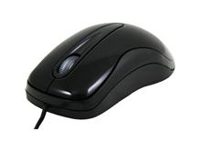**

|  |  |  |
| --- | --- | --- |
| Device | Features | Uses |
| Keyboard | Most keyboards have the following features:  • QWERTY key layout – the letters are laid out in a particular way  • Number pad – usually found to the right-hand side of the keyboard the number pad contains the number keys 0–9 and associated maths symbols  • Function bar – the function bar contains pre-programmed keys that perform functions such as turn on the wireless connection or lighten the screen display  • Arrow keys – these allow left/right and up/down movements on the screen | A keyboard is used to enter text into a computer system. |
| Mouse | Mice can move in any direction required.  There are several types of mouse:  • Wired/wireless (wireless can use radio frequency or Bluetooth receiver) mice work through sensors inside the mouse  • Optical mouse – uses LED  • Laser mouse – more sensitive | To assist with moving a cursor around the computer screen and selecting menu options and icons. |
| Microphone | • This input device records speech and sound. The user speaks into the input device.  • It can be omnidirectional to allow Internet audio to be converted | Entering audio, normally analogue.This is useful for users who have limited hand movement / difficulty typing. |
| Sensors  http://www.fiat.co.uk/uploadedImages/Fiatcouk/Accessories/Fiat_500/Safety_and_Infotainment/parking_sensors_50901737.jpg | • A sensor is a device that changes analogue to digital signals so the computer can process them.  • A sensor collects mostly analogue input –moisture, heat, pressure, etc.  • No human intervention is required.  • This input device is accurate. | To collect analogue data so that it can be processed by a computer system |
| Specialist keyboards  http://www.kenstone6.net/fcp_homepage/images_specialist_keyboard_fcp/03_specialist_keyboard_fcp.jpg | • These keyboards have keys that are specific to the application they are required for.  • The keyboard can be designed to suit the business application. | A numeric keyboard is used in accountancy firms.  A virtual keyboard, which can pop up on a screen, is used like a conventional keyboard.  Businesses, for example fast-food restaurants, can use a keyboard pre-programmed with specific keys for food items. |
| Remote controls | • Remote controls are designed to suit the application, e.g. they could have two buttons or several keys.  • They can be wired or wireless.  • They work using radio waves or infrared.  • The device they are operating needs to be in the line of sight. | Remote controls are used for gaming, operating televisions and home entertainment centres. |
| Scanners    http://www.netbanker.com/Images/scanner.jpg | • A beam of light is passed over the information to be captured which is reproduced according to the patterns of the light that make up the information.  • Scanners are available as hand-held or flat-bed scanners.  • The scanned information can be edited provided there is software that can convert the patterns of light into text. This is known as OCR (optical character recognition). | Scanners are used to enter large amounts of typed information and objects such as pictures into a computer system.  They are useful for entering information that does not need to be altered. |
| Digital cameras | • A digital camera takes digital photographs.  • The photographs can be uploaded to a computer system.  • The photographs can be saved onto a memory card inside the camera. | Digital cameras are used to take photographs that can be entered into a computer system. |
| Magnetic strips and chip and PIN  http://boakes.org/pics/2005/chipandpin/chipandpin.png | • A magnetic strip is a black strip on a plastic card and tends to hold static information.  • Chip and PIN refers to a card with a microchip and a PIN number that can process information.  • It is sometimes also called a smartcard. The card needs to be placed in a special terminal that can read the chip.  • The PIN entered is checked to see if it matches the PIN registered to the chip. If a match is identified, the required processing can take place. | Magnetic strips are useful for information that you do not want to alter.  Chip and PIN are useful for data that requires processing such as loyalty cards or bank cards. |
| MIDI instruments | • MIDI stands for musical instrument digital interface. | MIDI instruments are used for composing and entering music into a computer system. |

The healthcare industry use sensors to assist in patient care. Sensors indicate when a medicine cabinet door is opened and closed. This enables them to cut down on human checking costs.

USA airports employ several computer systems in order to not only improve efficiency but also security in light of the September 11th terrorist attacks. They use bio scanners to try to combat terrorism. Future Attribute Screening Technology (FAST) scans people as they walk by a set of cameras. The idea is similar to that of a lie detector test polygraph which looks for irregular swings in body temperature, breathing and pulse rates that might indicate anxiety. Those people suspected of anxiety are then interviewed in front of cameras that measure minute facial movements for signs they are lying. It is hoped this system will eventually be applied to train stations and other possible terrorist targets.

### Output devices

It is no good putting data into a system if the business cannot get the information out in the format they require.

#### Printer

The main feature of a printer is that it produces hard copy. This hard copy can be given to others to read, can be signed by hand, can be copied and can be scanned into a computer system for future reference. With the advent of the Internet and online shopping the printer tends not to be as popular as it was. However, it still has a place and is still an important **peripheral** in businesses. The speed is measured in how many pages per minute **(ppm)** a printer can produce.

Several types exist:

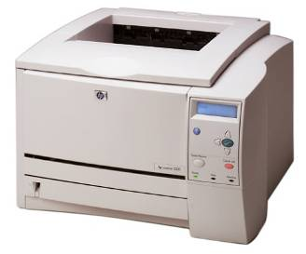Laser

A laser printer has a drum containing dust. When a printout is required the print image is magnetised and dust is drawn to the paper in the pattern of the image. This pattern of dust is then burnt into the paper in order for it to hold the pattern. A laser printer can be connected by wires or wirelessly to a stand-alone computer as a resource in a network. Modern laser printers can also be used as fax machines.

A laser printer can be quite expensive. They come in A3 and A4 size and the drums can hold coloured dust (more expensive than black) if colour printing is required. The image (text and/or graphics) is coated with the toner. Paper is pressed against this image and heated to melt the toner into the paper. The quality of this output is very good. Laser printers are fast and quiet which are benefits in busy office environments where both the level of noise and speed are important factors.

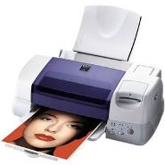Inkjet

An inkjet printer works by squirting tiny jets of coloured ink onto a page. It uses a combination of four colours. The image is built up using these varying dots of colour.

This type of printer is cheaper to purchase than a laser printer but it has very expensive running costs. Ink cartridges are expensive and do not last very long. Of course, it depends how often you use the printer and how much colour printing is on each page as to how long the cartridges will last.

Inkjet printers produce good quality printouts, although not as high quality as laser printers. As the printer has to squirt tiny dots of ink onto the page the process is slow and, therefore, is not suitable in a business environment. However, they are extremely useful for producing one-off colour prints.

Plotter

This output device produces diagrams by dotting pens on paper. Two types of plotter are available: a flatbed and a drum plotter. With the flatbed the paper stays still and a variety of pens dot the image on the paper. With the drum plotter the paper moves and the pens only move with horizontal motion back and forward across the page.

Plotters are very slow to print but can produce very large diagrams which makes them suitable for an architect’s office, kitchen designer or any organisation which has to produce large diagrams.

#### Monitor

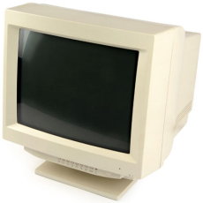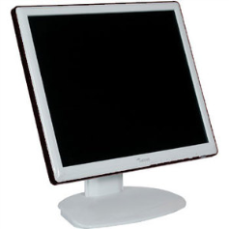

A monitor, also called a visual display unit (VDU), displays graphics, text and video on a screen. The actual picture is displayed as thousands of coloured dots called pixels. The quality of the picture depends on the number of pixels horizontally and vertically on the screen. This is known as the resolution. The higher the resolution is, the better the quality of the picture.

Two main types of monitor exist. The older type is the CRT (Cathode Ray Tube) monitor. Although they produce the highest quality output, use of CRT monitors has decreased rapidly since TFT (Thin Film Transistor) screens were introduced.

TFT are a type of LCD (Liquid Crystal Display) which provide greater picture quality. They are popular because they take up less desk space, and are lightweight even at large sizes.

#### Genius 2.0-CH SP-M120 Desktop Speakers ImageSpeakers

A speaker produces audio output provided the computer system has a sound card installed. Sound can be output on a computer through either headphones or speakers. Businesses tend to use audio output in automated telephone answering systems as it saves them having to employ a telephone receptionist for dealing with typical responses. Audio output is also useful for alarm systems in an organisation.

Speakers are also used to communicate publically with employees and customers in different industries, including retail supermarkets, railway stations and airports.

#### Head/earphones

These are personalised speakers in which the user wears a headset containing earphones. No one else can hear what the user is hearing. Because they are worn on the head, the user’s hands are free. This is handy for organisations that employ drivers. Employees that work in call centres and wish to cut out the noise of other employees talking can use headphones. Similarly, headphones can be used for entertainment, e.g. for listening to music.

#### Digital projector

The modern data projector is connected to a computer system and projects material on the computer screen onto a large whiteboard. In business this is used to enhance group discussion and aid presentations. The whiteboard can be interactive, meaning that the screen can accept input as well as output. Data projectors enhance conferences and presentations as the size of the projected screen improves clarity of materials and allows for staff participation.

**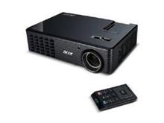**

#### Data projector

An ordinary data projector is an output device that projects material onto a large screen but is not interactive. This is cheaper than a digital projector and is popular for projecting video or displays in conferences or on bulletin boards.

### Software

A computer system cannot function without appropriate software. Firstly, operating system software, which allows the user to communicate with the computer, is required. Secondly, utility software, which assists with the day-to-day maintenance of the computer system, for example defragmentationand utility software, is also required. Finally, application software is needed and the type used will depend on the needs of the business. The following table gives some examples of software with examples of their features and purposes.

#### Operating systems

|  |  |  |
| --- | --- | --- |
| Software | Typical features | Purpose |
| Windows | • WIMP-based system  • Uses expanded memory  • Deals with error messages and user instructions  • Opens and closes programs  • Controls hardware | To provide a user interface for a Windows-based system. |
| OS X | • Used on a Mac  • Supports various languages such as Catalan, Croatian, Greek, Hebrew, etc.  • Multi-touch gestures  • Can have multiple, full-sized screens open at the same time  • Can open files at the exact same place that you closed down  • Automatic saving | Provides an interface for a Windows-based system. |
| Android | • The screen layout can be adapted to suit traditional layouts  • Most applications are written in Java  • It supports pressure sensors, certain gaming control and touch screens, etc. | Linux-based operating system that can be used on mobile devices such as smartphones. |
| iOS | • This interface uses buttons, sliders and switches  • Apps can be grouped into folders by can be created by dragging and dropping one app into another  • The home screen displays application icons | Used as Apple’s mobile operating system, e.g. on the iPhone. |

#### Utility Software

|  |  |  |
| --- | --- | --- |
| Computer security | • Scheduling of backups  • Can allow Internet backup which means you can access your data anywhere  • Can provide email reports which keep you informed about backup issues  • Disk checker – finds files that are corrupted  • Allows usernames and passwords  • Allows access rights to be set on files | To assist in the housekeeping of the computer system such as disk defragmentation, file deletion, system restores, etc. |

#### Application software

|  |  |  |
| --- | --- | --- |
| Software | Typical features | Purpose |
| Word processing | • Text formatting  • Text editing  • Templates  • Mail merge  • Incorporation of graphics  • Tables, borders, columns  • Text wrapping  • Macros  • Important/exporting  • Reviewing and facilities | To create and prepare documents. |
| Desktop publishing | • Similar to a word processor but with added publishing features  • Has more layout features  • Borders and shading  • Has more publishing features in terms of fonts, kerning, etc.  • Controls widows and orphans | Production of editorial documents. |
| Spreadsheet | • Can record data  • Can search data  • Can sort data  • Can enter various types of data  • Absolute and relative cell referencing  • Validation and conditional formatting  • Can perform calculations  • Can produce graphs and charts  • Can print in various formats  • Can import/export data  • Can use logic functions  • Can protect cells  • Can edit and manipulate data  • Can password-protect files  • Can make predictions using the ‘what if’ scenario | To display and process information (usually calculations) in a structured way. |
| Database  management software | • Create records, fields and files  • Tables can be linked – relational  • Primary keys can be set up  • Data can be queried  • Data can be sorted  • Customised reports can be created  • Can password-protect files  • Mail-merging facilities  • Online forms can be created | To organise data into a form manageable for efficient searching and sorting and report production. |

+

|  |  |  |
| --- | --- | --- |
| Software | Typical features | Purpose |
| Multimedia software | • Interactive  • This allows for the combination of text, graphics, video and audio in a presentation  • This makes the information more interesting and more meaningful  • Different forms of navigation  • Different storage file formats  • Allows for different paths through the software | Useful for businesses in the training of their employees. |
| Slideshow software | • Master slides can be produced  • Automatic slide timings can be set  • Slideshows can be looped  • Buttons can be added for manual timings  • Slide sizes can be manipulated according to their function  • Transition and animation effects | Suitable for audience presentations or in advertising, e.g. banners in shopping centres |
| Photo-editing software | • Allows importation and exportation of photographs into various documents  • Can set layers/masks in which photographs can be built up from others  • It has a lot of image-editing features such as cropping, etc. | Suitable for the manipulation of images. |
| Video-editing software | • This allows for the editing of videos, e.g. trimming of clips  • Images can be imported into the video  • Audio can be added  • Effects can be added, such as the fading in of frames | Suitable for a marketing business in which times and effects matter. |
| Graphics-manipulation software | • Graphics can be described as pictures or graphs.  • Can select and use various components  • Allows the use of vector or bitmapped graphics  • Has creating and editing tools such as freehand, cropping, etc.  • The user is able to select and use specialised enhancement tools such as filters and retouching  • Allows the saving of various file formats in the appropriate resolution | Suitable for any business that deals with graphics – from a photo graphics business to the production of model portfolios to web designers. |
| Communication software | • Used to send and receive data  • Can add attachments  • Can add signatures  • Can set auto response messages  • Can send to multiple recipients  • Contains tools to assist with communications | All businesses require this type of software for social networking, instant messaging, transferring files and emailing clients. |
| Presentation software | • Allows the presentation of data in various formats – digital, visual, print, web, etc.  • Allows for different pathways. | All businesses have to present information – from statistics to text to pictures. |

|  |  |  |
| --- | --- | --- |
| Software | Typical features | Purpose |
| Gaming software | • Enhancement tools for sound and video  • Creation of sprites  • Animation of objects  • Allows for different genres  • Contains tools for manipulation of various file formats | Used in the gaming industry – children’s games, educational games, adult games, etc. |
| Web-browsing software | • Enables a user to view web pages  • Allows the creation of bookmarks  • Allows navigation of the web with the back/forward button  • Enables the user to organise bookmarks and favourites  • The History function allows the user to record the websites visited  • Enables the user to refresh a page using the refresh button  • Enables the user to input URLs into the address bar  • Displays a status bar to inform the user of loading details | To allow the reading of web pages. |
| Apps for portable devices | • These work on any device  • They work as you move computers  • Files, etc. are not left on a PC  • Additional software is not required to run apps  • They can be used on removable drives | Suitable for use on a portable device such as a phone. |

A photographic studio would use graphics manipulation software to remove skin blemishes and attempt to make models appear thinner.

Computer-imaging software has been used to build a land resource database for the Arun River basin in Nepal, India. It is used to indicate forest degradation hotspots. Along with simulation models, the database helps to design and implement land management programmes.

An accountancy firm would use spreadsheets to record the business’ accounts.

Most businesses use databases to keep records of their customers and to assist with mail merge.

### Storage and connectivity devices

Business organisations have to consider the storage requirements of the systems they use. Not only do they consider the system memory available in which to store operating systems and application software, they must also consider external storage in terms of extra memory, security and employee accessibility.

Storage devices fit into several categories depending on the method that is used to store the data.

#### Optical disks

An optical disk looks very similar to a normal audio compact disk. Two popular types are Compact Disks (CDs) and Digital Versatile Disks (DVDs). There are many versions available in the modern market such as CD-R, CD-R/W, DVD-R/W and DVD-R. In terms of these extensions R means ‘read only’. Once the data is written to the disk it can be read as many times as necessary. The data on the disk, however, cannot be changed. This is known as WORM – write once, read many. R/Wmeans the diskcan be written to many times.

Compact Disc (CD)

[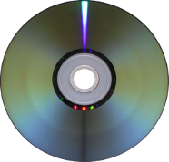](http://en.wikipedia.org/)A CD can store up to 650 MB of data in digital format on a single surface. This is done by using a red laser which burns the data onto the disk. Because data is burnt onto the CD this makes it more robust than many other magnetic media. It is quite cheap to purchase and its low weight, ease of packaging and portability make it an ideal medium for businesses to distribute software, audio and pictures. It is also a direct access medium which means that the data can be found quickly.

Digital Versatile Disc (DVD)

A DVD is read and written to the optical disk using a laser beam at speeds of approximately 150 KB per second. The DVD stores the data in two layers using a blue laser beam and this has the effect of doubling the amount of data that it can store. An average DVD can hold 17 GB of data. This makes it a more suitable medium for the distribution of high-definition video, pictures and sound.

Blu-Ray Disc (BD)

Blu-ray disks hold up to 25GB of data (single layer) or 50GB (dual layer). Used to store high definition video content, and video games, e.g. for Playstation 3.

Like CD/DVD drives, Blu-Ray -readable drives are a standard component of modern computers. However, at the time of writing this, if you want to write data to a Blu-Ray disc, a special (and expensive) drive is needed.

#### Magnetic media

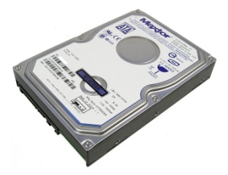These tend to be hard disks which are inside the computer system, portable hard disks which are external to the computer system and magnetic tape.

Internal hard disk and external hard disk

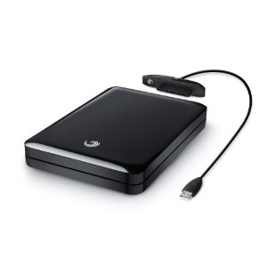Both of these storage devices can hold up to approximately 1.2 TB of data. Retrieval is fast because they are random access media and can transfer about 40 MB of data per second using hard disk drives (HDD).

The internal hard disk is contained inside the casing of the computer and the external hard drive is a separate, portable device. This form of storage is quite expensive compared to other forms of storage and, in the case of the internal hard drive, can slow the processing down if it gets too full.

Users tend to store the programs they are working on or have recently worked on in the internal hard drive while the external hard drive tends to be used as a backup medium. The internal hard drive tends to come with the computer system and, if required, the external hard disk is an added extra cost.

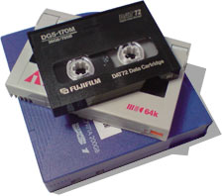Magnetic tape

Magnetic tape comes in the form of a tape cartridge. Special software is required to read the data to and from the tape as the data stored on the tape is very densely stored. This is a very cheap method of storing data compared to other storage methods as a lot of data can be stored on the cartridge. However, it is slow to read to and from and therefore, as it is good for business organisation backup, it tends to be carried out at night when the system is not in use. This does not affect the business as this can be done automatically by the computer system without any human intervention.

#### http://www.acousticpc.com/images/a_zalman_ssd_n_series_drive.jpgSolid State Drives

Solid-state refers to storage technology that does not have any moving mechanical parts. This differs from traditional magnetic storage such as hard disk drives, which are electromechanical devices containing spinning disks and movable read/write heads.

Advantages include better performance in terms of reduced failure rate and faster read/write speed. They are also silent, with no vibration, both due to lack of any moving parts. However they are currently more expensive than magnetic hard drives, and are currently only available at smaller storage capacities.

#### Memory cards

Flash based media such as memory cards are solid state in nature as they contain no moving parts. They come in many forms, such as pens or cards.

Memory pens are popular because they are very small, lightweight and portable. Their capacity (up to 5 GB) makes them an ideal personal storage medium for transferring data. Businesses such as Internet providers find them useful for assisting consumers to log their portable devices on to the Internet.

Memory cards, on the other hand, are more easily damaged than a pen. Although they hold less data than a pen (approximately 8 GB), they are useful as storage devices inside small portable devices such as digital cameras and mobile phones. They, too, are portable and cards can be inserted into different devices.

#### Network devices

**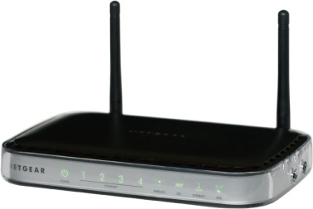**The main network devices are routers and modems, although there are others.

A router is a device that transfers data between two different networks. It finds the best route possible to send this data. If a business is trying to transfer data between networks of two different types or through the Internet (which is made up of differing systems), it requires a router. Routers can be either wired or wireless. Wireless is very popular with home computing, especially in homes where there are several computer systems (for example a portable computer, a netbook and a stand-alone device) trying to connect to the Internet. The router is connected to the main telephone cable coming into the house and the other computer systems can then be situated in different places around the home without the need for cables.

A modem transfers data from analogue to digital and vice versa. A computer works in digital form. When it wants to connect to the Internet it usually does so through analogue cables. A modem connected to the computer system is required to carry out this conversion. It also reverses the data coming from the Internet from analogue to digital back into the computer system. If a business wishes to have Internet access, even if only for email purposes, then it requires the computer system to have access to a modem, either an internal or external one.

Cloud storage

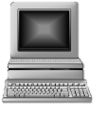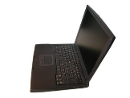

This is a method of storage in which a remote computer is used to store and process data. The user’s computer only holds the data while it is being used. The data is actually held on a ‘cloud’. The user does not, therefore, need a powerful or even large computer, a mobile phone will do. When necessary, they request the data they need from the higher powered computers which hold the data. These computers can be anywhere in the world. An example of cloud storage is iCloud, a service provided by Apple.

Cloud storage is useful for businesses as it reduces the need to purchase computers and storage. Instead, storage is treated as a utility service –the business pays another company to provide the storage and to deliver the data as and when needed. The main concern, however, is that of security. The business has no control over where their data stored.

### Configurations

Most offices have networked computer systems because they enable better control of the hardware, software and data in the system; offices can cut down on costs through sharing peripherals and systems can be used by multiple users. These networks can have various configurations called ‘topologies’.

#### Typical office configurations

‘Star’ topology

• All computers are connected to a central computer called a file server. This central computer holds the data and programs that allow the system to operate. They do this through a hubwhich copes with the data transfer.

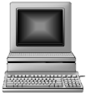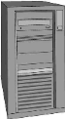

• If the central computer breaks, all the other computers cannot function.

• This configuration is expensive to install because each device has its own cable that connects it to the central computer.

• As each computer is connected separately to the main computer it does not relay or wait for data.

• Adding in extra peripherals or computers is easy to do.

Star networks are used to store data in a central server and allow other computers to send and receive data to and from this server quickly.

In a business environment this means all the data can be held in a secure location away from the computers accessing it.

‘Bus’ topology

• In this network all the computers are connected to one main cable.

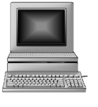

• Each computer sends and receives data along this cable.

• This means that if there is too much traffic, processing will be slow as each system will have to wait their turn.

• If the main cable breaks then the whole network will go down.

• It is cheaper than a star system because there is less cabling involved.

Bus networks are used to connect computers together cheaply.

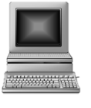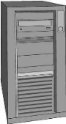

‘Ring’ topology

• In this network computers are linked in the form of a ring.

• Data travels around the ring and is deposited when it finds the computer it is looking for.

• Data can only travel one way around the ring.

• It does not necessarily need to have a file server.

Ring networks are used to connect computers together when a file server is not necessarily present. It is suitable for linking a small number of computers.

#### Customised systems for specified needs

A business is only successful if it has customers. Customers have varying requirements. For example, a shoe that contains GPS technology has made its way onto the market. The GPS shoes have a tracking device implanted into the sole of one of the shoes and a GSM antenna in the heel. The shoe also includes a USB port for charging the battery. The idea behind this product is to monitor the ‘wandering’ habits of those with Alzheimer’s disease or dementia. The wearer of the shoe is ‘allowed’ a certain walking area and if the person wanders outside this area then a SMS message is sent to the ‘carer’ of the person, alerting them of this fact.

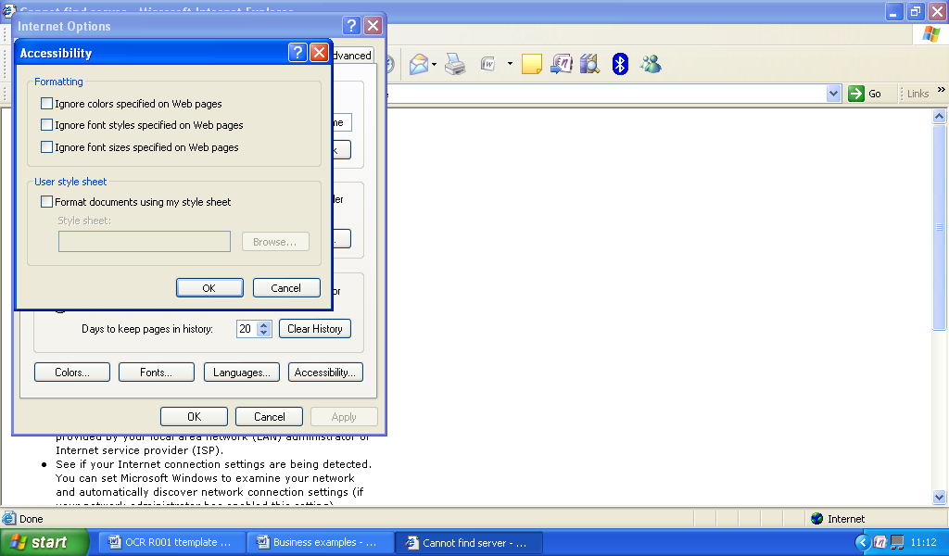Physical impairment

The blind / poor-sighted rely heavily on the computer keyboard and expanded text and prefer audio instructions rather than text-based instructions. Screen magnifiers, Braille keyboards and software which speaks text are all necessary components of a computer system designed for this type of user. Web browsers have several accessibility options (see the screenshot to the right) which enable dyslexic users to manage the display of writing and colours on a web page.

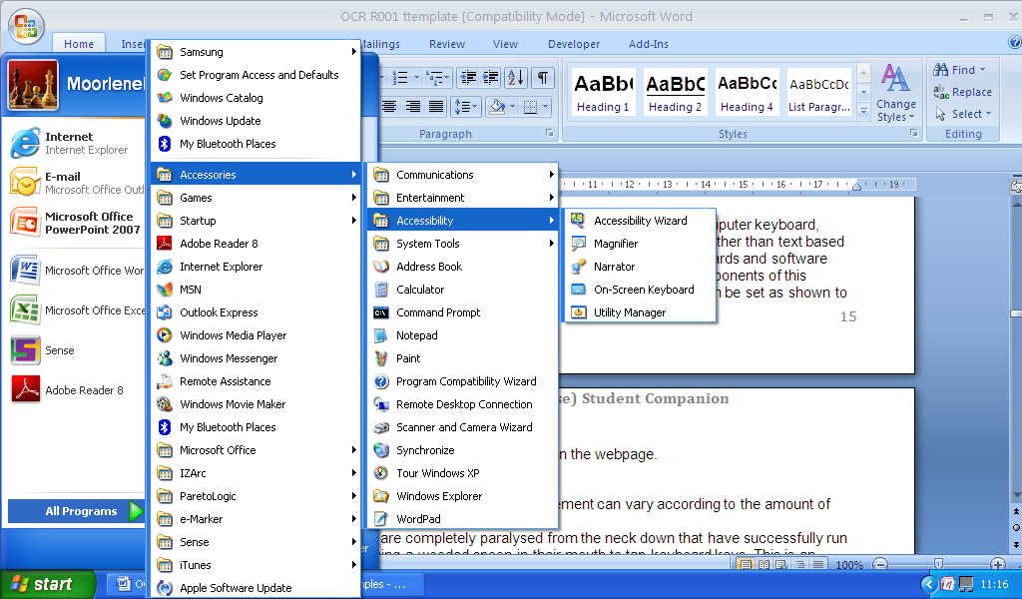

The system software also allows the user to select other options, such as magnification the screen, narration of the text and the display of a keyboard on the screen, as shown in the screenshot.

Another type of user with special requirements are people with limited physical movement. Systems designed for this type of user can vary according to the amount of physical limitation.

There are cases of people that are completely paralysed from the neck down who have successfully run computerised businesses by using a wooden spoon in their mouth to tap keyboard keys. This is an extreme example but computer systems can be adapted to assist users with physical limitation. The following are some examples:

|  |  |
| --- | --- |
| • use auto complete for text  • display large icons  • customised mouse  • audio commands  • adapted mouse and key guards  • communication aids such as Braille keyboards | • specialised software  • screen magnifiers  • overlay keyboards  • switches |

People with hearing problems also require specialised computer systems. Hearing problems vary and ranges from those that have limited hearing to those that cannot cope with too much noise.

More typical features designed to aid this type of user are setting visual warnings on the screen or converting sound to on-screen text. One of the newer features to assist with this is the disable/enable sound feature in web pages.

Remote working

Specialised systems are also required for people who work remotely. If an employee needs to travel a lot, not only does he/she need to be able to work while on the move, e.g. on a train, aeroplane or car, he/she also needs to be able to work from home, from hotels or from other countries.

Many trains have Internet access and facilities to enable mobile workers to plug in a laptop. Airports now allow Internet access, usually at a price, and, during the flight, mobile phones can now be set to ‘airplane mode’ enabling their (limited) use in the air. It is also now standard practice for the airline host/hostess to announce when the use of technical equipment such as laptops and tablets is permitted.

Cars can have GPS systems plugged in to allow routes to be planned and mobile devices can have their batteries recharged. Hotels now use Wi-Fi Internet access as one of their marketing features, either through enabling a customer to connect their own computer to the Internet or enabling access through the bedroom television. Mobile phone roaming also allows communications from various countries.

Teleworkers are employees that work from home. They, too, require specialised systems. Normally, a router plugged into the mains telephone connection enables various computers, laptop or stand-alone computer, to access the Internet. The different computer systems can be in different parts of the home.

All this technology allows for email, videoconferencing and online storage depending on what the user requires.



#### LO1: Test yourself – Features and purposes of computing devices

1. Suggest three ways a smartphone can assist a salesman who is required to travel for his work.

2. A business has decided that its monitors need to be replaced to make them more employee-friendly. Explain what features the business would need to consider when deciding which new monitors to purchase?

3. Mr Jones is an advertising designer. Due to family constraints he has asked if he can telework. Explain what he would require in terms of hardware and software.

## Factors affecting the choice of ICT system

Before deciding on any system a business has to ask itself the following questions.

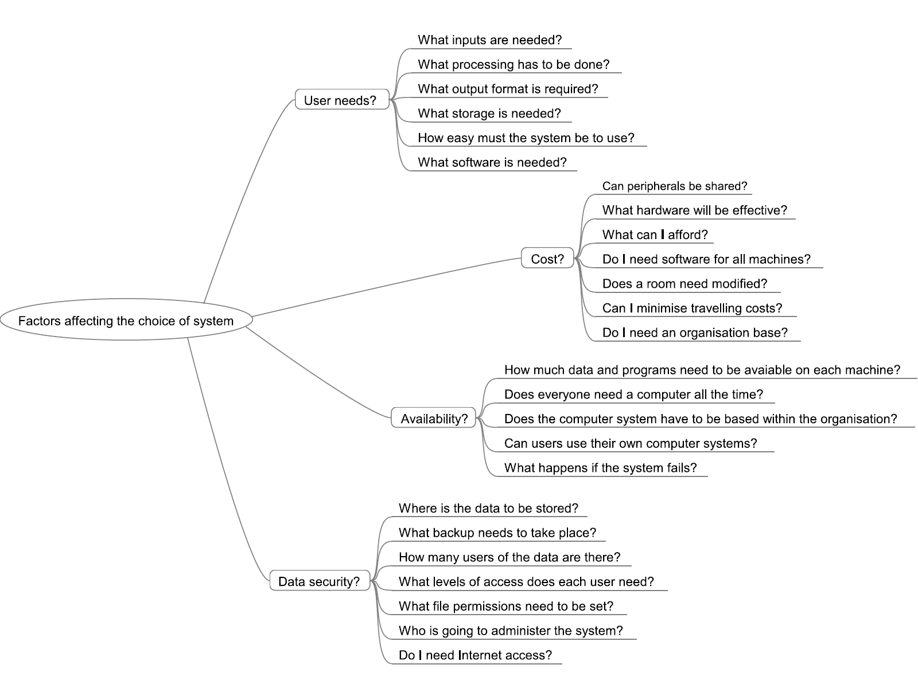



#### LO1: Test yourself – Factors affecting the choice of ICT system

1. Mary wants to buy a new computer system so she can continue her school work at home. Suggest considerations she must take into account when deciding what to buy.

2. A school requires a new set of computers for the IT room. What factors would influence which computers they decide to purchase?

3. Data security is a consideration when a business chooses a computer system. Explain what needs to be considered.



#### LO1: Test yourself – Factors affecting the choice of ICT system

1. Mary wants to buy a new computer system so she can continue her school work at home. Suggest what she must consider when deciding what to buy?

2. A school requires a new set of computers for the IT room. What factors would influence its decision.

3. Data security is a consideration when a business chooses a computer system. Explain what needs to be considered.

## Connecting peripherals to computer devices

All peripherals, e.g. printers, digital cameras, mice or external devices, require connection to computer systems. They can be connected using wires or wirelessly.

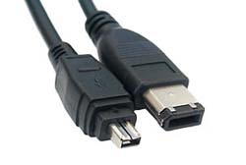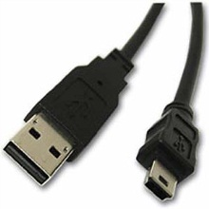

### Wired methods

Peripherals that use wires tend to be connected through one of the ports available on the computer system.

USB devices include pen drives and Internet dongles. The receiving computer needs appropriate driver software on the system to enable recognition of the plugged-in device.

Another method of connection is called Firewire. Firewire permits up to 63 devices to connect to its bus. It allows information to be quickly transferred between digital devices, such as digital cameras, home entertainment centres, printers and scanners, and computer systems. In modern terms it is classed as a plug-and-play device,as when you plug the device in to the port, the operation system automatically detects it, applies the appropriate driver software if present and, if not, asks for the software source. Its long-distance capability allows equipment to be placed in businesses at appropriate locations.

### Wireless methods

#### Wi-Fi

Wireless Fidelity (Wi-Fi) is used to connect computers or other hardware together that come within range of each other. Each device requires a wireless adapter. Other computers can join the network provided they are within range. A hotspot is required – a site that offers Internet access by using a router connected to an ISP. The user opts to connect wirelessly and inputs a password to connect to the ISP. This hotspot or AP (access point) can also act as a connector between a wired network and a non-wired network.

#### Bluetooth

**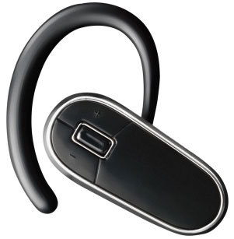**Bluetooth is another wireless technology that allows devices such as phones, etc. to communicate over short distances. Bluetooth may already be installed in a device and thus a driver is not required. The idea is to pair one device to another using a passcode which is exchanged between the two devices. The first device asks for the password the user invents and then the second device asks for it. When the password is given correctly the two devices can communicate. Bluetooth is very popular for sending photos to your phone, sending voice from a headset to a mobile phone or backing up PDA data to a mobile phone.

#### Infrared

Connecting peripherals using infrared requires infrared adapters. This is usually an external device connected to a PC computer system and an internal device in, for example, a mobile phone. Although it has the advantage of not needing cables, the two devices trying to connect must be in direct line of sight. Businesses usually use infrared for computer mice and printers. Infrared is also used for night vision and hyperspectral imaging such as that used in security systems.



#### LO1: Test yourself – Connecting peripherals to computer devices

1. Explain how data can be sent from one mobile phone to another within the same room.

2. Explain how a school can set up a network using wireless laptops.

3. John has a computer and a wireless printer. Explain how he can get his computer to transfer data to the printer.

## Connecting a computing device to a wireless network

Apart from requiring the appropriate technology and software on the devices you are trying to connect, mostly for security reasons, there are some other features required for the connection to be successful. The following are some examples:

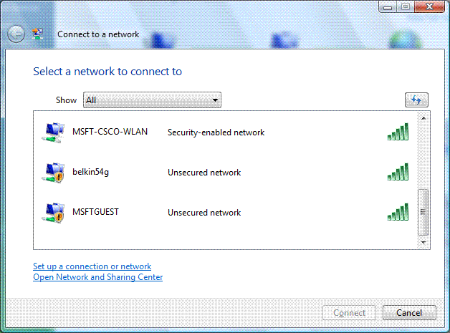

### Network name (SSID)

An SSID (service set identifier) is the name of a wireless local area network (WLAN). All wireless devices wishing to connect must use the same SSID in order to communicate with each other.

If a network is hidden then an SSID can be entered manually. It is also possible for a public SSID to be broadcast from an access point to all wireless devices that are within range of each other.

### Security keys

Security keys are used to exchange messages between devices. These are commonly encrypted with WEP (Wired Equivalent Privacy). This is set through the network router setup wizard. It is a sequence of hex digits chosen by a network administrator and assists with securing the network connection. As with all technology WEP has been superseded by WPA(Wi-Fi Protected Access) and WPA2 which provide greater security.

### Firewall settings for public and private networks

#### Public

The firewall setting is applied when a connection to a domain is made through a public network, e.g. hotel airport, coffee shop. A network profile is dynamic – it recognises how the computer connects to the network and changes automatically. The actual security is controlled through the operating system. It is applied to a network adapter when applied to a public network. The user sets the profile.

#### Private

The firewall setting is applied to a network adapter when it is connected to a network that is identified by the user or administrator as a private network. A private network setting is one not directly connected to the Internet but is behind some kind of security device such as a NAT router or hardware firewall. It is set through the operating system.



#### LO1: Test yourself – Connecting a computing device to a wireless network

1. What is the difference between a public and a private network?

2. What is a network security key?

3. How does SSID work?

## How organisations can monitor employees

#### GPS location tracking

A GPS satellite is able to continuously record its location and current time. It can also work out the distance from it to a receiver, a device such as a satnav system inside a car. When three or four satellites record this information they are able to pinpoint exactly where the receiver is by calculating the amount of time it takes for the signals to reach the receiver.

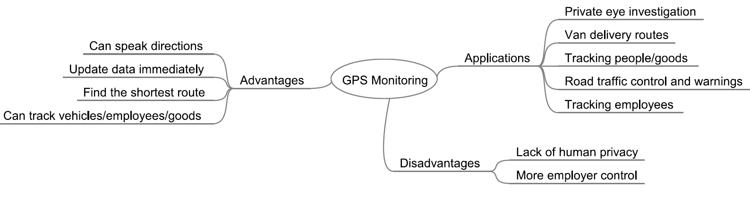

#### 

#### Monitoring Internet use

Popular methods of monitoring Internet use include: installing appropriate software on a system that logs usage; setting the operating system; or looking at the web browser history.

### 

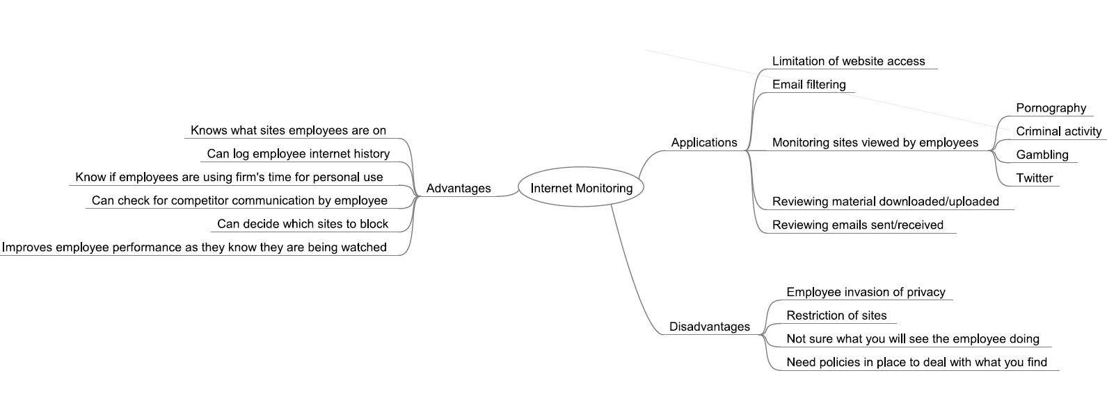



#### Monitoring communications

It is possible to install mobile phone surveillance programs which allow the installer to read emails.

### 

If a snap election was called in Northern Ireland there is no local firm capable of printing the large ballot papers used in our Single Transferable Vote (STV) system.

The news comes as the Electoral Office tests electronic counting as a means of avoiding the delays for which it was criticised last year.

The e-counting method under consideration would still require conventional voting slips.

Once these ballots are scanned into a computer the votes are counted and transfers allocated almost instantaneously.

Last month the Northern Whig, which traditionally fulfilled the contract for our ballot papers, ceased trading and made its 21 employees redundant.

*Belfast Telegraph, 03/03/2012*



#### LO1: Test yourself – How organisations can monitor employees

1. Employee monitoring causes friction with employees. Suggest some reasons why an employee might feel unhappy about being monitored.

2. Why might an employer choose to monitor employee Internet use?

3. A business has decided to install GPS systems in all its delivery vans. Explain how the benefits might outweigh the costs.

# LO2 Know how to work with information and data to meet specified business needs

All business systems have to collect data before they can process it into useful business information.

Collected data has to be accurate or the processing results will be wrong. In addition, the data has to be collected efficiently or it will cost the company in terms of money, assets and time.

## Data capture methods

### http://www.ixbt.com/short/images/paper_form_pv.jpgOnline and paper-based forms

Paper-based forms are a manual method of collecting data.

Paper-based surveys can be used to identify shopping habits or restaurant efficiency, for example.

Paper-based forms can be posted to customers for completion. Examples include disability, job seeker’s allowance and voting forms.

Paper-based forms are not popular as they are slow to collect, slow to process, and, if posted, cost more money. In addition, errors are not immediately detected and, in some cases, forms are not returned.

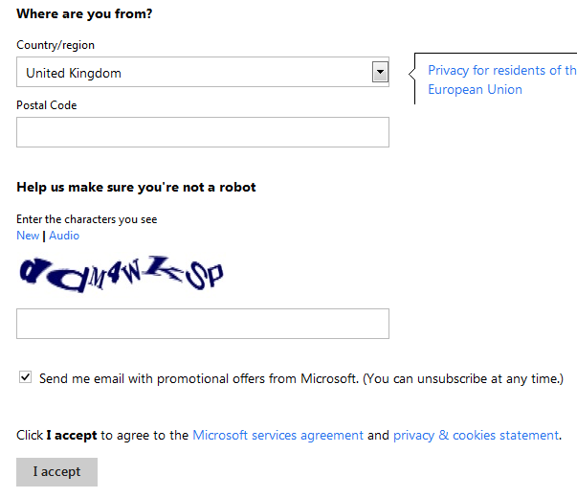Paper-based forms are gradually being replaced by online forms. Online forms require a computer operator, or even the users themselves, to enter the data into a form template shown on a computer screen.

This type of form is used for online shopping surveys, VAT returns, ticket booking systems and hotel bookings. An advantage over the manually filled-in form (paper-based) is that validation software can be applied to the online form thus helping to reduce errors. In addition, because the data is being entered immediately into a computer system, the processing of this data is more efficient.

### Automated data capture systems

Automated data capture systems do not require humans to be present.

**Control system sensors** (e.g. heat, light, moisture sensors)

These measure analogue data and then use an ADC (analogue to digital convertor) to turn the analogue signals into digital signals which a computer can process. Once entered into the computer system, this data can be processed and graphs, etc. can be produced of the data. If the processed data has to be fed back into the system to control what happens next, this is regarded as **feedback**.

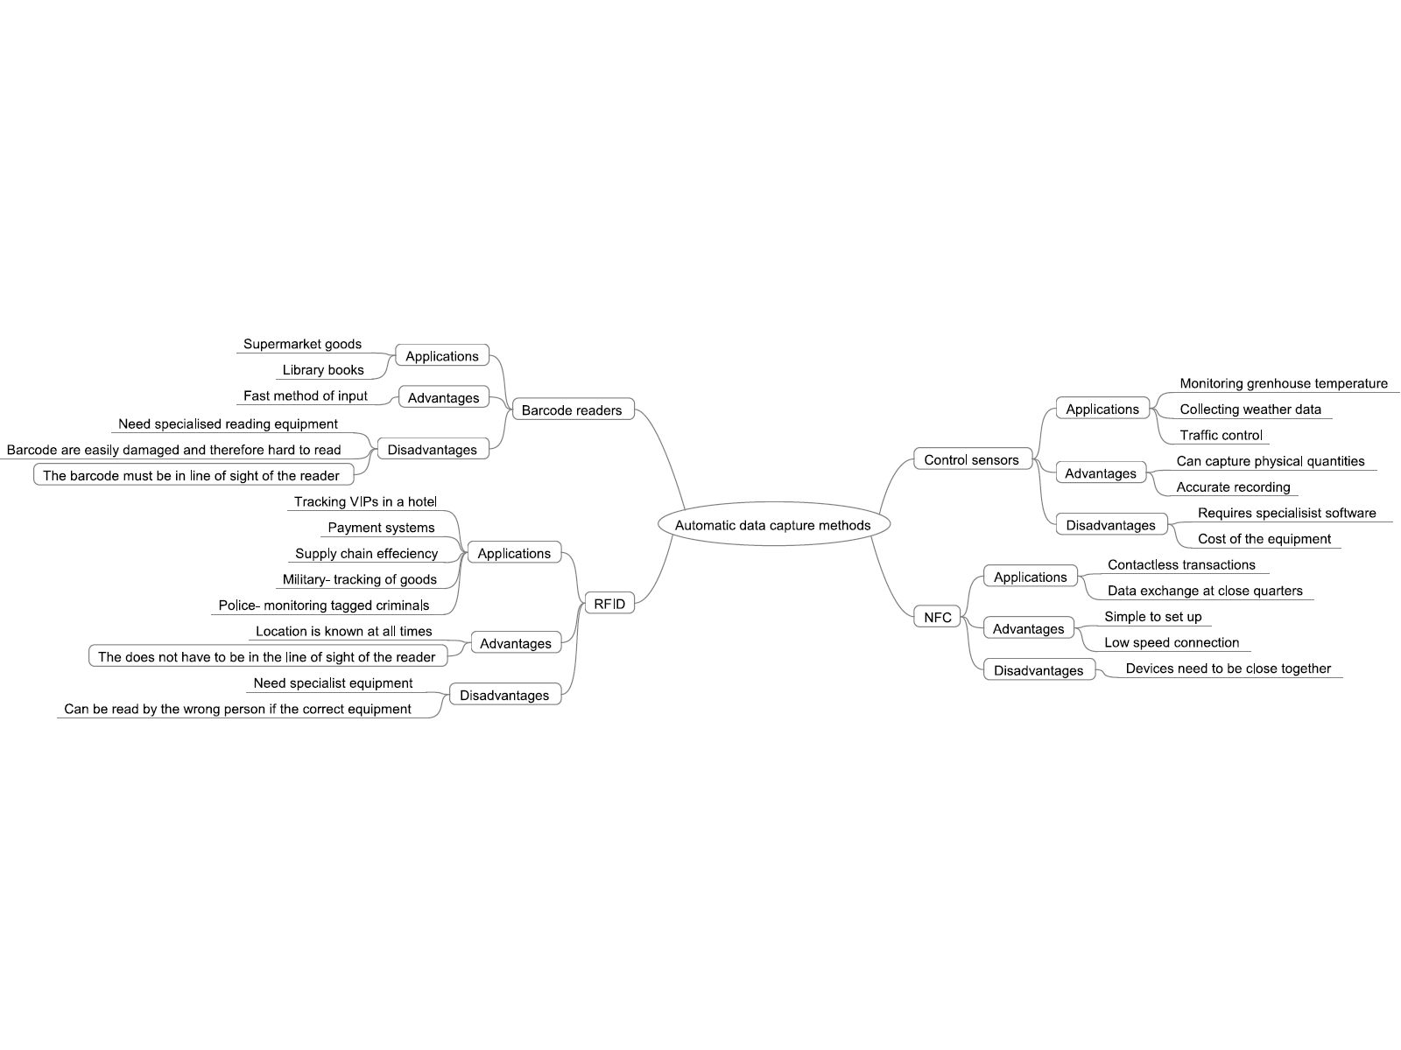

#### barcode readerBarcode readers

Barcode readers read barcodes which are attached to products.

A barcode is a series of thick and thin, dark and light lines which are read by a laser.

The barcode contains the product code, the manufacturer code, the country of origin and a check digit. It is normally accompanied by a 13-digit number which can be manually entered if the reader cannot read the code. Barcode readers are normally used in supermarkets where the barcode is scanned at the point of sale (POS) terminal and the data is compared to the overall stock database in the main computer system, and the price, etc. is returned to the POS to assist with the customer bill.



#### http://smallbiztrends.com/wp-content/uploads/2011/02/rfid-large.jpgRadio frequency identification device (RFID)

An RFID is a radio frequency identification system that consists of three components. An RFID tag/transponder microchip is electronically programmed with unique information and contains an antenna which uses radio signals to read and write to the tag when it is within reach of the RFID reader. It then passes the information to and from the host computer in digital form so processing can take place. The information contained on the tag can be for used for identification or location.

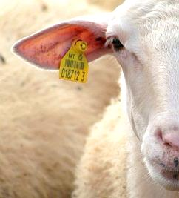RFID tags are gradually replacing barcodes as they can hold varying types of information and do not need to be in line of sight of the reader. Paying for meals at drive-through restaurants and paying at road toll gates without stopping are some examples. Everyday uses include tracking animals (as shown on the right) and goods in a retail store (security).



The Baja Beach Club in Barcelona implant RFID tags into arms of patrons of the VIP section. The microchip has a barcode and it emits small radio frequency identification (RFID) signals.

Any information loaded on to the chip is displayed on a computer screen in the club. This means that the club can keep track of their VIPs and serve them accordingly. The tag not only identifies the person but functions as a debit tag. Many of the customers only wear bathing suits so this eliminates having to carry purses or wallets.

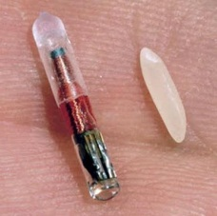

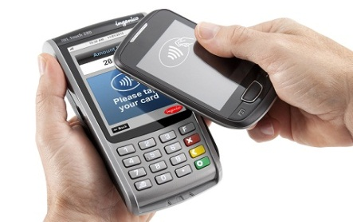Near field communication (NFC)

NFC is a set of standards that establishes radio communications between devices, such as smartphones, when they are very close together or touching. This means the device does not have to be physically connected to a device in order to transfer information. For example, football stadiums are experimenting with allowing members entry to the grounds by waving mobile phones at an NFC reader. Payment for goods can also be made by waving a phone near the specified receiver.





#### LO2: Test yourself – Data capture methods

1. What are the advantages of online data capture forms over paper-based forms?

2. Football stadiums are experimenting with near field communication which enables members to enter the grounds after they have waved their mobile phone at a turnstile. Discuss the problems with this use of technology.

3. State with justification two areas in which data capture methods involving sensors would be suitable.

## Factors affecting the choice of data collection method

The nature of the business or organisation affects the choice of the method of input. Where the business is based, where the customers are based, what processing has to take place, how much money the company has, how much security has to be applied to the data right down to how skilled the organisation staff are all need consideration. The following factors must be taken into account:

### Nature of information to be collected

#### Environmental conditions

• Paper-based methods of data capture are not environmentally friendly

• Whether the information to be collected is analogue or digital

#### Location of information

• Information collected centrally lends itself to online collection over manual collection

• Postal information needs to be collected

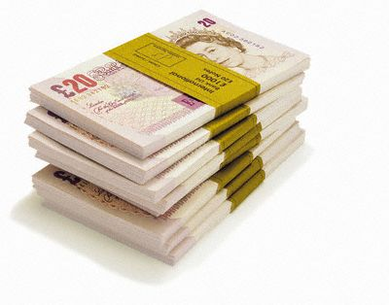• Does the collected information have to be close to the processing site?

### Cost

#### Source document

• Time cost required to prepare the data, e.g. staff wages

• Financial cost in terms of paper, postage, etc.

#### Data entry processing

• If it has to be done quickly then staff costs will be higher

• If edits are required to be made to the data, the whole process will take longer

• The amount of data that has to be keyed in – the more data, the longer it takes

• The legibility of the document, e.g. handwriting, etc., if it is illegible then it takes longer and so more cost is involved

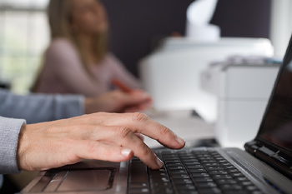• If data is to be scanned, cost is affected by:

o size of the document

o uniformity of the pages

o document condition

o arrangement of the pages, e.g. double-sided

o quality of the paper

o whether batch processing of documents can be used

### Availability

• Paper is readily available for manual collection whereas as barcodes and magnetic cards have to be specially produced

• Availability of staff to prepare and collect the information – e.g. offshore employees, teleworkers

### Ease of use

• What ability has the person giving the information, e.g. a child

• Form design

• OMR lends itself to the collection of marks in predefined places

• OCR lends itself to the collection of typed text

• Handwritten data capture lends itself to manual forms

• Complexity of the data collected

• Keyboard suitable for low volumes of text

• Automatic data capture means less/no human intervention

### Data security

• No human intervention then data is more secure

• Consideration has to be given to where the source documents are held

• How many people have to use the source material before it gets processed

During 2006 approximately 780,000 people used online techniques, such as assistive technology and on-screen reader software, to complete the Australian census. The software had to allow the user to ‘save the data’ and be able to return to it to ‘alter’ and ‘check’ the data. Security methods employed included encryption of the data during transmission, decryption for processing and decryption when sending back to the user for altering. Only authorised ABS (Australian Bureau of Statistics) officers could view the data. Some forms still had to be collected manually and, therefore, the data collectors needed to identify those who had completed the form online. They did this by ensuring that the software sent an SMS message to the data collectors when an online form had been completed.

The reasoning behind using the e-census was:

• better for the disabled

• more convenient, more flexible

• data was kept private

• needed fewer data collectors to give out and collect forms

• more efficient processing

• fewer printed materials

• easy for the people to complete

• easier for the government to collate the statistics

However, all did not go smoothly:

• Not all the population were IT literate.

• The software had to be compatible with the wide variety of web browsers.

• The software had to perform well over slow dial-up connections.

• The system had to allow for the fact that the majority of the people submitted on the night the census was due in.



#### LO2: Test yourself – Factors affecting the choice of data collection method

1. Explain four factors that need to be considered when deciding what method to choose for collecting data.

2. Explain how the location of the information to be collected affects the choice of data capture method.

3. When would an employer decide to use OMR instead of OCR?

## How to design data capture forms to obtain specified information

The successful collection of the data, whether manual or online, relies on the efficiency and design of the data capture form.

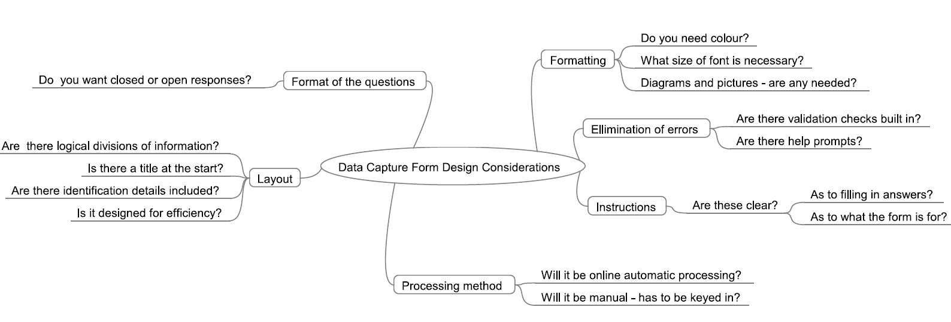



#### LO2: Test yourself – Designing data capture forms

1. Suggest three areas that need to be considered when designing data capture forms.

2. Explain how a data capture form can be designed to try to reduce input errors.

3. State what is meant by a logical layout when designing a data capture form.

## Coding information for use in a spreadsheet or database

Businesses need to code information for various needs:

• Privacy – coded information is more private

• Ease of entry – it is faster and easier to enter data

• Less memory is needed in the computer system

• Validation can be applied more easily

However, they need to be careful that the codes are understandable, easy to remember and any used do not reduce accuracy.

Below are some examples of coded data.

**M/F** Male/Female

**Y/N** Yes/No

**12/02/12** 12th February 2012

**NY**  New York

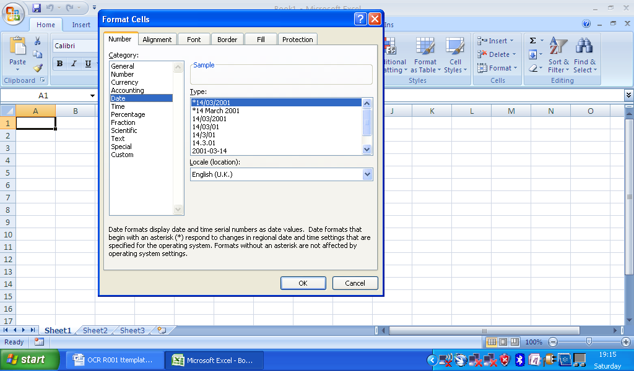Once the data is collected it will need to be inserted into a spreadsheet and, therefore, any text will need to be converted to numerical information as spreadsheets cannot manipulate text very well.

Take the popular types of data capture questions:

Male/Female?

Yes/No?

What is your opinion of the service? Excellent/Satisfactory/Unsatisfactory

How do you travel to school? Bus/Car/Cycle/Walk

The idea when coding this information is to turn it into numbers.

Male/Female? Y = 1 and N = 0

Yes/No? Y = 1 and N = 0

What is your opinion of the service? Excellent (1) / Satisfactory (2) / Unsatisfactory (3)

How do you travel to school? Bus (1) / Car (2) / Cycle (3) / Walk (4)

This would mean a data capture form can be turned into something resembling the following:

|  |  |  |  |  |
| --- | --- | --- | --- | --- |
| Name | Male/Female | Are you under 14 (yes/no)? | How do you travel to school? | Are you happy with the school dinners? |
| Mary | 0 | 1 | 2 | 1 |
| Bill | 1 | 0 | 3 | 3 |
| William | 1 | 1 | 1 | 3 |

A **database** is also a popular method for processing data. Like in a spreadsheet, the data needs to be coded to save memory and speed up data entry/processing. Coding methods can be similar to those discussed above but, as the database can manipulate text much easier, it is also possible to enter the data not only as number codes but also as text codes. The rule, however, is still to make the codes easy to remember.

Examples:

**BB** Bed and Breakfast **NYK** New York

**FB** Full Board **LON** London

**HF** Half Board **BEL** Belfast



#### LO2: Test yourself – Coding information in spreadsheets and databases

1. What is the purpose of coding data?

2. A survey is being conducted to collect information on whether children travel to school by car, bus, bicycle or on foot. Suggest a possible way to code this information for use in a spreadsheet.3. State what is meant by a logical layout when designing a data capture form.

3. Suggest two problems with coding data.

## Data validation methods

Accuracy is forefront in all business organisations. If you input inaccurate information then inaccurate results will be output. The acronym GIGO (garbage in, garbage out) is used to describe this process.

Data validation is the process of ensuring that the information input is reasonable and correct. Several types of validation exist.

|  |  |  |
| --- | --- | --- |
| Method | Description | Examples |
| Type | This is when the data entered must conform to a certain pattern | • A date: three sets of two numbers separated by an oblique (/) –12/02/12  • Several letters followed by some numbers such as in a password or a postcode |
| Range | Making sure the data entered falls within a specified upper limit and a lower limit | • Test results have a score between 0 and 100  • Pensioners have to be over 65  • Drivers must be over 17 |
| Length | This is when entered data must be of a certain length | • 10 characters such as in a password  • A barcode must be 13 digits |
| Presence | This is when there must be some data entered | • Making sure a surname has been entered into a field  • Making sure a box has been ticked |

Examples of spreadsheet and database validation:

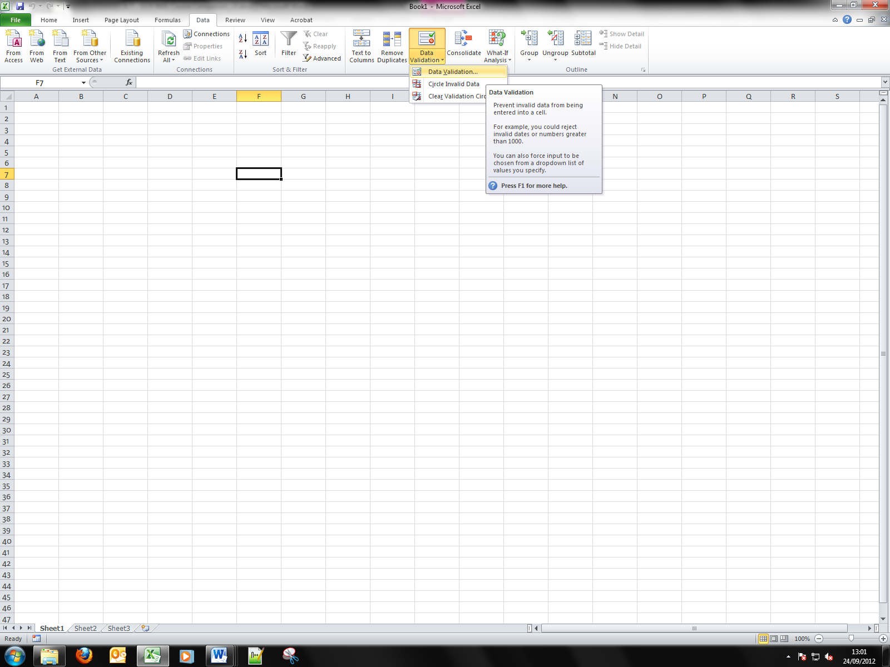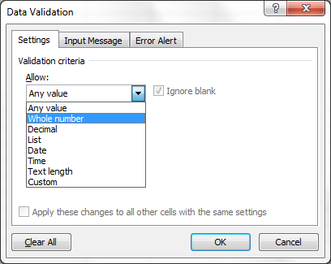

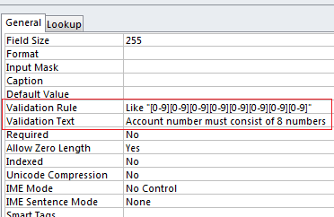

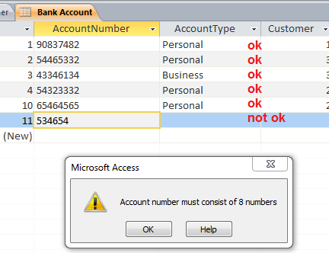

#### LO2: Test yourself – Data validation methods

1. What is data validation?

2. What is meant by GIGO?

3. Explain the following types of validation check: (A) Range (B) Length

## File formats for storing data

Businesses do not necessarily have the same software on all their systems as a lot depends on the function of the system, e.g. an accounting section may use spreadsheet, word-processing and database software, the receptionist might use calendar and diary software as well as a word processor and the marketing department might use desktop publishing software, a word processor, presentation software, audio software and graphics software. Not only is the software different within sections in a business but it is also different from other businesses it communicates with, e.g. different firms use different word processors. Regardless of the software used, data needs to be coded in some sort of standard format so that it can be exported and imported easily into other systems. Most software now allows work to be saved as various formats and the following are just a few examples.

### Proprietary formats

A proprietary format is a format that is not readily available as it is connected with a particular software package.

|  |  |  |
| --- | --- | --- |
| Extension | Associated with | Specific information |
| .doc | Documents | MS Word extension |
| .xls | Spreadsheets | MS Excel extension |
| .ppt | Presentations | MS PowerPoint extension |
| .fla | Multimedia authoring | Adobe Flash extension |
| .wma | Audio | Windows Media extension |
| .aac | Audio | • Associated with MPEG-2 Advanced Audio Coding File  • An encoding system for digital audio |

### Open formats

An open format is associated with software that is freely available for public use.

|  |  |  |
| --- | --- | --- |
| Extension | Definition | Specific information |
| .rtf | Rich Text Format | • Allows users to transfer data between different applications  • Opened using a variety of word-processing applications |
| .pdf | Portable Document Format | • Used to represent documents in a manner independent of application software, hardware, and operating systems  • Commonly used for publishing documents online |
| .csv | Comma-Separated Variable | • Uses commas to separate tabular data in plain-text format  • Used to import files directly into a database or spreadsheet |
| .exe | An executable file | • Associated with an executable program by Microsoft |
| .txt | Text file | • Stores characters as plain-text, without any formatting |
| .mp3 | MPEG-1 Audio Layer 3 | • Compressed recordings that leave out the noises that are not detectable by the human ear |
| .wav | Waveform Audio | • An audio file format used as the source for encoding other formats |



#### LO2: Test yourself – File formats for storing data

1. What is meant by an open file format?

2. State which of the following file formats would be the most suitable for business distribution of a pamphlet: DOC, PDF, CSV.

3. Which file format is suitable for importing files into a database or a spreadsheet?

## Data storage technologies

### 

### 

### Local and removable media

#### Hard disk technology

A hard disk is the magnetic storage inside a computer system and has a large capacity. In a business environment the hard disk is used for working memory and software. It can get filled up quite quickly and this memory can be susceptible to viruses and damage as it is in constant use. Organisations, therefore, tend to take periodic backups using either magnetic tape or an external hard disk provided they have the appropriate software. This requires organised backup on a regular basis at a time when the computer system is not in demand by the company to ensure business efficiency.

#### External hard disk

Many businesses purchase an external hard disk as a backup device but this is an expensive form of backup and can be limited in size. If the business expands, it will have to rethink its backup solution. The external hard drive is connected to the main system and data is periodically sent to it for safety.

#### Magnetic tape

Although magnetic tapes are a cheaper and more compact form of storage, they require careful management. The insertion of the magnetic tape cartridges into the system has to be planned for; however, after this the computer can be automatically set to start software which records the system data onto the backup. This process can be lengthy and needs to be set so it does not interfere with normal business working practices.

#### DVD/CD

This optical media stores data which has been burnt onto the CD/DVD using a DVD/CD writer. Although quite robust, the storage capacity is limited and does not suit all business environments.

#### Memory stick

This storage device uses solid-state memory to record the data. The memory stick is plugged into one of the USB ports and the required data is saved onto the memory stick. Although very easy to use, its small, portable size makes it easy to lose and it tends to be only used to back up a small amount of work.

### Remote storage

#### Off-site location

A company will send its critical data to a location away from the main site as part of its safety plan. The data is usually stored in the off-site location as either magnetic tape or optical storage which has to be manually sent to the off-site location as and when necessary. The organisation can have a dedicated off-site location such as a special vault or system, or it might purchase storage from another business. In either case the organisation needs to weigh up the benefits of having dedicated locations against the financial cost. It does mean, however, that, should something happen to the working business data such as a fire, theft or flood, the business can be up and running very shortly after.

#### Cloud storage

This is storage which is provided by an Internet-based off-site system. The data is downloaded and uploaded through the Internet as and when it is needed.

The organisation subscribes to a cloud storage provider to whom they send the information to be stored over the Internet. This provider records the data it is storing for the organisation. When the organisation wishes to retrieve the data, they make a request, using the Internet, to the storage provider who then either sends the data back to the organisation or allows the organisation to manipulate the data it is holding. To ensure data safety the provider stores the data on multiple data servers. The advantages are:

• It does not rely on location.

• Data can be accessed from anywhere.

• It is easy to share files.

• The data can be maintained based on personal needs.

• There is instant recovery of data.

• More data can be backed up on a daily basis.

• It is more cost-effective as you buy what you need and only when you need it from a cloud storage provider.

However, many businesses fear that their data could be prone to cyber theft.



#### LO2: Test yourself – Data storage technologies

1. What is meant by off-site data storage?

2. What is meant by cloud storage?

3. Why might a business opt to use cloud storage?

## Security measures to be used when storing data

The storage of data is one of the most important areas in any business organisation regardless of the size of the business. Lack of security can mean the hacking of data by competitors, people with a grudge against the company, fraudsters, blackmailers or, indeed, anyone who thinks they could have something to gain by disrupting, destroying or stealing the information.

### Network/computer security

#### Usernames/passwords

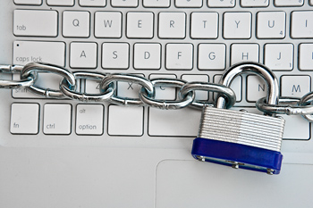A username is not necessarily a unique name that allows a user to gain access to a particular area on a network. A password is also required and this is a unique code that enables the user to log on to their individual files within this certain file or area on a computer system. The network system administrator sets the username. They decide what the user desktop should contain in terms of application software and what security they want to apply to this area. The username is then given to a group of people. These people can access this group of files but to keep their work in this area individual they also have to use a password which has to be set uniquely by each individual user to the system.

Password and user files are both stored on the computer system. When the user enters the password and/or username this is compared to a list of passwords/usernames stored on the computer system. If a match is found, the user is allowed to enter the designated area.

#### Access rights/permissions

Every document/file on a network can be set to have certain access rights and permissions. These tend to be read-only or read/write and are set by the network administrator. This means access can be restricted to certain groups and thus assists with security issues. For example, in a business context, a salesperson does not need to access payroll files and wages and payroll personnel do not need to access the sales figures.

Levels of access can also be set in which different people are granted access to different levels of permissions. For example, in a classroom a junior pupil might be completely restricted to what they see on the screen in front of them, whereas a more senior pupil not only can gain access to a screen, they might also be allowed to change the size of the icons or the background for themselves.

### Document security

With the advent of remote computing document security is even more important. Some security you can set yourself through the file or through special document security software.

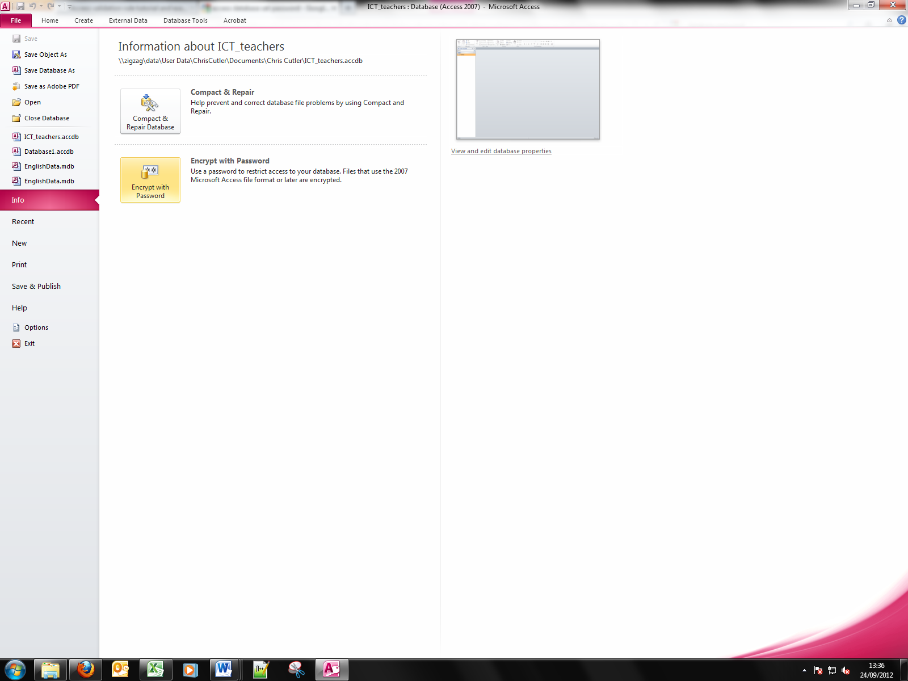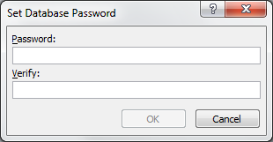

The main method of document security is through the use of passwords but there are others which are indicated below.

#### Passwords

Passwords can also be set within the software as well.

This tends to be set by the user of the document and it is their responsibility to administer this password.

Features of a good password

Users need to be careful that others do not get access to their password and, therefore, they need to make sure it is:

• not easy to guess

• long – at least eight characters

• a combination of letters and numbers

• not written down where others would find it

• changed regularly

• not a word found in a dictionary

• not shared with anyone else

• unique to the area they are using

#### Other ways to restrict access to or editing of content

• Restrict email permission, e.g. block the sending of attachments

• Use a business watermark on documents which will deter people from passed the documents on

• Set permissions on the document, e.g. a print request automatically generates an email to the correct person who will either decline or accept this request

• Give a document a level of protection if it is being shared, e.g. lock down a document if it is sent outside an organisation

• Set a document expiration time – time bomb

• Use software which does not allow editing such as PDF software

• Use software which can wipe out documents when necessary

• Track access on mobile documents in terms of locations and user identity

• Encrypt any data sent

• Lock files as read-only, etc.

• Install software that alerts to any updates being carried out

• Use good anti-malware tools

#### How and why data is encrypted

Encryption is designed to prevent unauthorised people from reading data. This is extremely important when client and organisations have to send information, such as credit card details, across the Internet when banking or booking airline tickets, etc.

The idea behind encryption is that the data is scrambled (encoded) before being transmitted across a network so that unauthorised users cannot read it. At the receiving end the authorised user has to decrypt the data in order to read it. The sender and the receiver need access to software that encrypts and decrypts the data.

### Physical security to prevent loss of data/devices

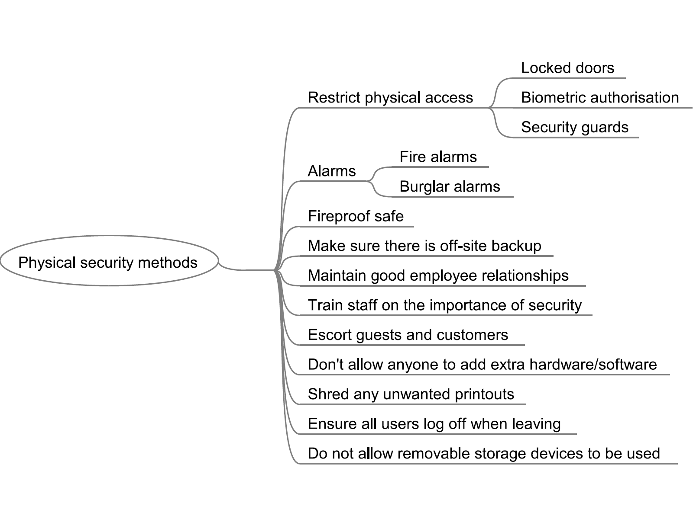



#### LO2: Test yourself – Security measures to be used when storing data

1. An organisation insists that its employees change their password every week. Explain why this is good practice.

2. A company likes to keep good relations with their employees. In terms of security explain why this is important.

3. Suggest three ways a document/file can be protected from unauthorised access.

## Data transferring technologies

### Wired and wireless methods

#### Wired methods

|  |  |
| --- | --- |
| ADSL | • Cheaper because it can use ordinary telephone lines  • Can use the traditional phone line at the same time  • Transfer rates are faster than a conventional modem  • The connection is ‘always on’ |
| Fibre optic | • Expensive to install as it is a speedy method of transmission which uses light beams to carry data  • Connections are not available in many areas  • Very fast secure data transmission – high bandwidth  • Can transmit data over exceptionally long distances without much data loss  • More manageable than normal cable |

#### Wireless methods

|  |  |
| --- | --- |
| Bluetooth | • Wireless transmission using radio waves  • Devices find and communicate with each other if they are in range  • Suitable for small devices such as a mouse because the hardware is small  • Much lower power requirement than Wi-Fi  • Obstacles can hinder transmission  • Has a range of up to 10 m  • Maximum transfer rate of about 24 Mbps |
| 304px-Wi-Fi_LogoWi-Fi | • Has a range up to 100 m  • Maximum transfer rate of about 54 Mbps  • Normal transfer rate of 721 Kbps  • Uses a wireless network interface card (NIC)  • As the number of stations that can join the network increase, the performance decreases  • Normally requires an access point |

#### Mobile data transmission

|  |  |
| --- | --- |
| 3G | • Wireless transmission using radio waves  • Devices find and communicate with each other if they are in range  • Suitable for small devices such as a mouse because the hardware is small  • Much lower power requirement than Wi-Fi  • Obstacles can hinder transmission  • Has a range of up to 10 m  • Maximum transfer rate is about 2 Mbps |
| 4G | • Successor to 3G  http://images.clipart.com/thb/thb9/PH/images/45382416.thb.jpg?1001643523• Uses Open Wireless Architecture – supports multiple wireless air interfaces  • High speed transferability – from 100 Mbps to 1 Gbps  • Security measures  • Greater information exchange capabilities |

### Remote methods

|  |  |
| --- | --- |
| Email | • You need an email client such as Outlook  • The client allows you to create a message, save it, add attachments, send it, etc.  • You need an email client which keeps your email account  • The sender creates an email, the client passes the message to the server which in turn can send it on to the receiver’s server from which the client can retrieve the message |
| Internet / cloud | • A cloud system is essentially a collection of different architectures that hold data and software either by choice or for a business and which can deliver data and software resources to any system that pays for its service (sometimes it is free)  • It does this through a web-based interface  • Resources are given as services through the Internet |
| Peer-to-peer file sharing | • Need to have a network of people who also want to share files  • Each computer requires special software – this software points to a network tracker which gives your computer information about the computers connected to it  • An account is then created in which you can specify which files you want to share  • Each computer is both the client and the server of the other computer  • This means that if one system breaks, the others can keep functioning  • File sharing can often break software copyright laws |

### Security methods

Businesses need to have an understanding of how the security methods work before they decide which method to employ.

#### 

#### Data encryption

Data encryption is the process of scrambling information using an algorithm (cipher) to make it unreadable to anyone except those possessing the key. The person receiving the message is given the key so that they can unscramble it and thus read the message.

### Factors affecting the choice of method

|  |  |
| --- | --- |
| Factor | Points for consideration |
| File size | A large file needs a fast transmission speed or it will take too long to upload/download the information. |
| Transfer speed | • Wireless methods of transmission tend to have a slower transfer speed.  • The more volume of traffic the slower the transfer speed will be.  • Some data storage methods are serial access and others are random access. This affects the transfer speed when trying to recover specific data. |
| Future-proofing | Some data transferring technologies are affected if you need to expand the network. |
| Data security | Wireless transfer methods and portable storage devices are less secure. |
| User needs | • Where the user has to access the data.  • The speed at which the user requires the data to be transferred. |



#### LO2: Test yourself – Data transferring methods

1. When choosing a data-transferring technology what factors does a business need to consider?

2. Explain how data encryption works.

3. Explain why a business should use Wi-Fi for connecting laptops to a computer system instead of Bluetooth.

## Factors affecting data transfer speed

|  |  |
| --- | --- |
| Factor | Points for consideration |
| Bandwidth | • Bandwidth refers to the range of frequencies through which data can be transmitted. It is measured in bits per second.  The wider the bandwidth the more data can be carried and, therefore, the faster the transmission speed.  • Bandwidth is important in some technologies such as videoconferencing as the voice must match up with lip movement.  • Different technologies have different bandwidths such as ADSL and fibre optic. |
| Router technology | • Different systems have different transmission methods.  • A router is a hardware device which connects two or more networks together.  • It works out the best route for each packet of data to travel along.  • It divides the data up into packets, sends the packets the shortest routes and then reassembles the packets when the data reaches its destination. |



#### LO2: Test yourself – Factors affecting data transfer speed

1. What is meant by bandwidth?

2. How might bandwidth influence transmission speed?

3. What is a router?

## Factors affecting the optimisation of electronic files

Optimisation is the process of reducing file size for online use.

|  |  |
| --- | --- |
| Factor | Points for consideration |
| Download speeds | Download speed can affect the sync of the media when downloading if the file is too large. |
| Quality of product | • Optimisation can affect picture quality depending on the method used.  • The file format designated to the data affects the quality as some file formats relate to compressed files.  • Optimisation can affect audio quality which, again, depends on how the file is compressed. |



#### LO2: Test yourself – Factors affecting the optimisation of electronic files

1. What is optimisation?

2. How can poor optimisation affect the quality of a product?

3. Explain one method of communication in which optimisation is very important.

## Backup and recovery systems

### Data storage media

#### http://www.techfresh.net/wp-content/uploads/2007/11/mf_nu2_1.jpgRemovable storage

These tend to be systems that are organised and controlled by the user of the data. For example, the user can back up a file onto a pen drive or can copy the contents of their personal PC onto a CD or DVD. This is fine but it puts the emphasis of remembering to take the backup and the secure storage of the data onto the user and humans are less reliable than machinery.

#### Remote storage

Remotely storing data on something like cloud storage can be done automatically at pre-set times. The data is automatically sent at the requested time to the remote server who then is responsible for its security ad storage. The user has also got the ability to send data to the remote server as and when they wish.

### Backup frequency

The frequency of the backup depends on the method employed.

On-site magnetic backup, such as magnetic tape, tends to be performed once a day (usually at night) using an automatic backup feature in the backup software. Three generations of tapes are kept; this is known as the ‘grandfather, father, son’ principle. This means that, should something happen to the data, the grandfather is used to restore the data along with the addition of the transaction data that has taken place since the grandfather was taken. If the grandfather fails, the father is used and, should this fail, the son is available. If the business has to deal with a large quantity of data then backups are taken more often.

If the method is portable, such as a pen drive or DVD, backup tends to be carried out as and when it is required. For example, when someone completes a piece of work they might make a second copy on a portable device.

### Archiving

An archive tends to be the backup of data for long-term storage. The user does not expect to retrieve this data but it is there in case they have to. In this storage the medium has to have a long shelf life. Online storage, in this instance, might not be appropriate as it is a utility provided by a company and no one can be sure as to how long this company will continue to function.

### Automated versus manual systems

|  |  |  |
| --- | --- | --- |
| System | Advantages | Disadvantages |
| Automated system | • Do not have to remember to take the backup  • Automated systems usually compress the data | • Reliance on a system to take a backup  • Usually harder to retrieve the data  • Required specialised software |
| Manual system | • More control of the data in terms  of security | • Must remember to take the backup |



#### LO2: Test yourself – Backup and recovery systems

1. What is the difference between a backup and an archive?

2. A large organisation is considering a backup strategy in which they will back up data once per week. Explain why this is a bad idea.

3. Why it is better to have an automatic backup system rather than a manual one?

## Factors affecting the choice of backup method

|  |  |
| --- | --- |
| Factor | Points for consideration |
| Cost | • How often do you have to back up?  • What volume of data needs to be backed up?  • How often must the backup be carried out?  • What is the lifespan of the backup media?  • What type of backup is needed – full backup or incremental?  • Do you want to pay extra expense to have the backup equipment on your own site?  • Do you want to pay monthly for an online service?  • Do you need backup software?  • Does the method allow for data expansion – future-proofing? |
| Availability | • Do you need access to it when you travel? Is it portable?  • Do you need Internet access to retrieve it?  • Is the system reliable and not prone to failure? |
| Ease of use | • Do you want online backup where it is collected, compressed and encrypted and then automatically transferred back to the remote servers?  • How easy is the recovery process?  • Can on-site backup be carried out with minimum disruption? |
| Data security | • Internal or external storage – which is more secure?  • Is the location of the storage secure?  • What security is applied to the actual data? If using online storage, is the data encrypted?  • How reliable is the company providing the backup service – could it cease trading in the future and, if so, what happens to the data it deals with? |



#### LO2: Test yourself – Factors affecting the choice of backup method

1. What factors does an organisation have to consider when deciding on the choice of backup?

2. What is meant by an incremental backup?

3. Give three considerations a company needs to make when taking a backup?

# LO3 How ICT can be used to support business working practices

## How businesses communicate with employees and others working remotely

All businesses have to communicate. The following are some of the most popular methods that can benefit a business provided they are appropriately used.

### Appropriate use of remote communication tools

#### Voice telephones

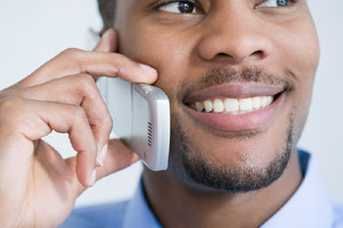This is the standard method of audio communication with much of the world having appropriate telephone cables. However, there are still many areas of the world (e.g. remote areas) in which standard telephone cables do not exist. This is due to the high cost of laying the cables. Furthermore, businesses have to aware that country-to-country telephone communication (when it does exist) can be very expensive, especially if the calls are lengthy.

On the other hand, there is immediate feedback provided the receiver answers the telephone. A previous disadvantage of telephone communication, that users cannot see each other, has been addressed with modern technology in that a video calls can now be made.

#### SMS

With the advent of the mobile phone, which went some way to address the problem of lack of communication cables, so too came SMS (short message service). The majority of people now have mobile phones and many businesses even provide mobile phones for business use. Using SMS is cheaper than phoning. The user needs to be fairly proficient at typing and aware of texting netiquette for it to be a valuable method of communication. However, predictive text is now an added feature. In terms of a business perspective SMS can allow the:

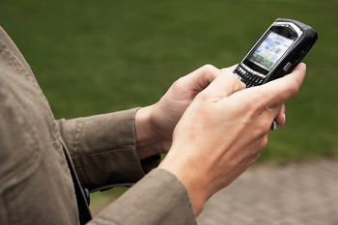• Sending of a message to many employees at once

• Identification of an employee as it has a sender ID

• Recording what has been sent

Examples of how a business can use SMS:

• Informing customers of a new product launch

• Sending short notes to thank customers for their custom

• Asking customers to fill in short satisfaction surveys

• Reminding staff and customers of appointments

• Advertising and promotion gimmicks such as a free cup of coffee

• Sending alerts. e.g. if a flight or appointment has been delayed

Communication is key in the development of India’s technology. Data is sent by the government and,   
as necessary, collected by the receiver. One such system is M4G (Mobile for Good) which uses mobile phone technology. It is a system that allows you to subscribe to receive job listings and health information. People type the job they are looking for on a mobile phone followed by ‘On’ to receive SMS announcements of vacancies. Charging is carried out according to the number of SMS messages received. HIV/AIDS information, breast cancer, diabetes and diet information can also be sent to the population in the same way.

#### Instant messaging

Instant messaging is a popular method of communication. Messages are sent in real-time and responses are instantaneous. Instant messaging allows many people to participate in a conversation at the same time, without running up a large telephone bill. As well as text, files such as documents and pictures can also be included in instant messages.

Other benefits include:

• Employees can be in various worldwide locations

• Employees can get information from another employee while on the phone with someone else

• Employees can see who is logged on at the same time as them

• They can see what another person’s current status is, e.g. away from desk

Two disadvantages are that emotions and meaning cannot be expressed as well as they can when having face-to-face or telephone conversations and viruses can be spread through files that are shared.

#### Email

Probably one of the most popular forms of business communication at the moment is email. Email communication can be external or internal. Internal is restricted to communication within a firm and is therefore more secure. External means communication can take place with anyone outside the firm, provided the parties communicating have the appropriate hardware and software.

Below are just some of the features which make email perfect as a business application:

• A message can be sent anywhere in the world at any time

• Attachments, such as documents or zip files can be sent

• Multiple emails can be sent at the same time

• Messages can be hidden from other receivers

• Email messages are free to send

#### Chat room

A business can set up a private chat room for communication instead of holding a meeting. This is carried out through the Internet and the business can specify which members/employees can get access to the chat room. It is also possible to post pictures but it is possibly less secure.

#### Forums

A forum is an Internet-based communication method. A community can be created on the forum for people with shared interests. Posts can be posted at any time for permitted viewers of the forum to participate in.

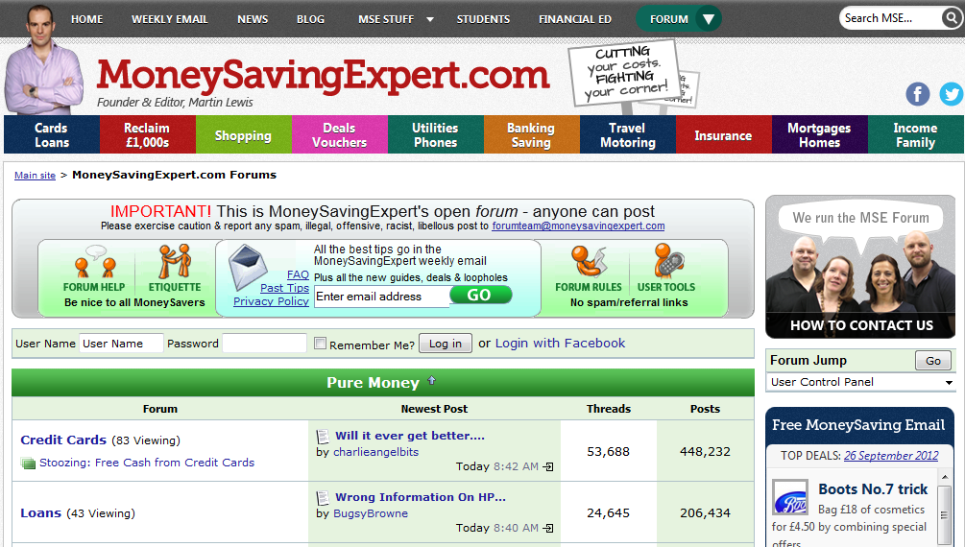Communication only takes place at the convenience of the individuals involved. If necessary, permission within the forum can be altered by the creator to allow some to read and others to alter the materials.

Popular uses within the business environment are:

• Marketing – offer forum members special discounts on products in return for information

• Allowing interaction to discuss business products or ideas

• Discuss troubleshooting of a product where the forum can be managed by a professional in the field of the problem

#### Bulletin boards

This is system software that allows users to read news and bulletins, exchange messages or use chat rooms and upload and download software. It can be internal, e.g. a company’s intranet, or external, on the Internet. Messages are left on boards for others to read.

Popular uses within the business environment include:

• A platform to develop ideas

• A platform to publish company news

• A motivational board where company/employee goals can be displayed

• A way of enhancing employee knowledge by displaying customer profiles

• A health and safety notice board, e.g. giving tips on avoiding stress

#### Voice over Internet Protocol (VoIP)

This is the technology for the delivery of voice communications over IP networks such as the Internet or other packet-switched networks. This is popular with any business that has automated answer phone systems that are capable of redirecting incoming calls to the right people or right section. With regard to call centre businesses this eliminates the need to employ people for this task and thus reduces costs. Other businesses, such as electricity services, allow customers to enter metre readings using VoIP. It is less expensive than videoconferencing, means employees can do business anywhere, allows the use of three-way calls and the recording features mean podcasts can be made of the communications to assist with training staff. One of the most popular examples of this at present is Skype.

Derbyshire Fire and Rescue makes extensive use of information and [communications technology](http://www.publictechnology.net/modules.php?op=modload&name=News&file=article&sid=12363) (ICT) to support its service delivery, with all its departments and 31 fire stations connected to a WAN for data sharing and the delivery of applications such as a management information system (MIS), which provides incident reporting and performance analysis.

The service also uses VoIP links for communication between major sites. When a fire officer arrives at a remote station, he/she can log in from anywhere in the building without having to track down a spare network cable. Employees are able to ‘hot desk’.

The service is currently looking into an automated system for loading new maps and map-based data onto fire appliances. Automating the updates will provide fire and rescue teams with greater insight into emergency situations and improve civilian safety. New maps can be pushed out whenever there is a change to the database, rather than at quarterly intervals as currently dictated by manpower considerations.

Also a communications system will enable ambulance teams to diagnose and begin treating critically ill patients before they reach hospital. A new communications system between a moving ambulance and its hospital base allows the simultaneous transmission of bandwidth-hungry video and ultrasonic images, telephone communications and patient data, all at the same time.

Putting a ‘virtual doctor’ in ambulance medical teams means that vital and detailed information about the patient’s condition can be gathered and the ambulance team can seek advice on patient treatment as they rush towards the hospital.

#### Videoconferencing

This is a method of conferencing that uses more than one computer system and in which each person on the system can see and talk to the other person. The initial set-up for this system is expensive as it involves audio and video, which require a high bandwidth, and the appropriate hardware and software. However, if set up correctly it can save a business time, travel, energy and money, and participants can see each other as well as talk to each other.

Popular uses within the business environment:

• Allows multinational companies to hold meetings with employees in different locations

• Using home webcams assists with teleworking

• Can transfer informative presentations if required

• Assists with the on-site training of employees

• Allows for a product demonstration from outside the business

• Enables off-site interaction with employees

• Enables the conducting of off-site interviews

#### Webcams

This section refers to the uses of a webcam not including videoconferencing. Normally a webcam is attached to the top of a computer monitor but it can also be placed strategically within an organisation to act as a security camera.

Popular uses within the business environment include:

• Employees can see each other as well as speak

• Employers can monitor an employee at work

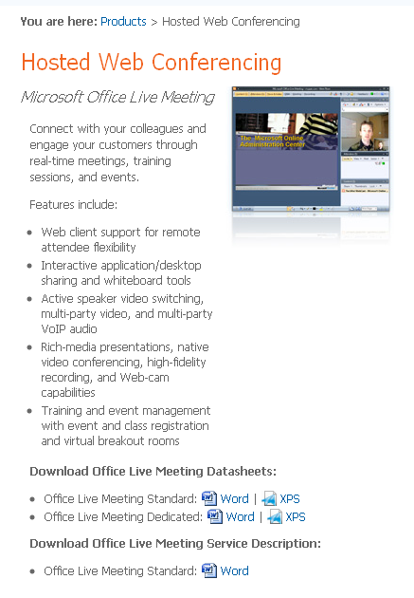• Employers can monitor the status of projects without leaving their office

• Monitoring when an employee leaves a computer system

• Recording an employee working to use as a training video

• Webcams can be used at trade shows to take pictures of potential customer details which can then be turned into text and stored in address books for future contact

• Can be used as a security surveillance camera

• The encouragement of teleworking

#### Blogs

A blog is a personal diary or journal of activities or news that is published on the Internet. It is easier for a business to update than having a website presence and the blog is publically available.

Popular uses within the business environment include:

• Share ideas with interested parties and receive feedback

• Can directly market to a target audience, e.g. readers can receive information on a regular basis instead of a newsletter

• Can encourage marketing interest by advertising incentives such as free samples

• Can share solutions

• Can connect a request with the appropriate expertise

#### Facebook.svgSocial networking websites

Social networking websites assist the building of social relations among people who, for example, share interests, activities, backgrounds, or real-life connections. Two popular social networking websites include Facebook and Google Plus, which both gives users different ways to communicate such as posting messages, pictures and videos. Each user has their own profile and can communicate with people they know by adding them as ‘friends’. These friends can be categorised into different groups, for example friends, family, co-workers, etc.

LinkedIn is a social networking site. Much like Facebook, LinkedIn allows members to connect with other users on the network, although LinkedIn is geared more toward professional connections.

Popular uses within the business environment include:

• Helps to build a sense of community among employees

• Low-cost way to advertise to millions globally

• Allows recruiters to screen candidates through information found on these sites

• Can market – by getting advertising space they can they offer prizes

• Allows valuable information to be distributed in an inexpensive way, e.g. health information

### The benefits and drawbacks of these methods

The benefits and drawbacks of these methods have been discussed in the individual sections above.

It is up to a business to determine what its objectives are and choose the appropriate method of communication. The following criteria must be taken into account:

• The speed of communication

• The security of the communication method

• The hardware and software required

• The privacy of the data

• The amount of information to be communicated

• The type of information to be communicated

• The number of people who have to receive the information

• The impact that the information needs to have



#### LO3: Test yourself – How businesses communicate remotely

1. What are the benefits to an employee of using SMS as a means of communication?

2. What type of information could a company display on a bulletin board?

3. Why might a business want a social networking presence?

## How diary management software can be used to organise work schedules

With the increase of the global market and the advent of the teleworking and outsourcing, a business can only survive if is operated efficiently. Traditional paper diaries are time-consuming to use and have been replaced by diary-management software which increases efficiency with regard to managing bookings, daily responsibilities, resources, rooms and venues across the whole of an organisation. Keeping a business diary helps to analyse working experience and identify possible issues within the business.

### Creating appointments/meetings

With regard to appointments and meetings, the following are some of the features of diary-management software that assist with the organisation of meetings and appointments.

• A diary can be viewed in weekly, monthly or calendar view

• Different time formats are available, e.g. 12-hour/24-hour or Paris/London, etc.

• Certain dates can be blocked out such as holidays

• Appointment lists can be printed off for convenience

• Multiple diaries can be booked simultaneously such as a venue diary and an employee diary

• Bookings can be associated with a particular room or venue

• An appointment can be scheduled against a company group

• Resources needed for a meeting can be booked

• Can allow others to access the diary

### Inviting participants

Meetings always involve participants, whether they are employees or clients. Diary software can:

• Allow you to choose who to send the message to

• Display client history to enable the user to know the client’s background

• Automatically inform participants of the meeting

• Automatically thank people for attending

### Creating tasks

Poor organisation relates to poor business efficiency. Diary-management software can:

• Allocate deadline dates

• Prioritise

• Set completion symbols

• Show/hide completed tasks

• Assign a task to a category

• Set overdue tasks

### Creating to-do lists

In the same way, diary-management software can aid with the planning of individual tasks. It can:

• Divide jobs into individual tasks

• Show these tasks on a daily and weekly basis

• Prioritise

• Use predictive text

• Embed graphics

• Group and sort entries

### Setting reminders

No matter how organised an organisation is, if it is under pressure, it might forget to do something. Diary-management software also provides reminders in the form of text messages, highlighted text or alarms. Thus, the software can:

• Set an ‘alarm’

• Remind of tasks

• Remind of meetings

• Remind of resources needed

• Remind all those involved



#### LO3: Test yourself – Use of diary management software to organise work

1. Suggest how diary-management software can assist with the organisation of business appointments.

2. Why might a business manager want to give others access to his diary?

3. How might the creating tasks feature of diary-management software assist a business?

## How documents can be created and edited collaboratively

A collaborative document is one that can be created and edited by more than one person. The traditional way was to pass paper back and forward between editors but, nowadays, this is done by computer.

### Documents in shared access locations

Documents for collaborative working need to be stored in areas that can be conveniently accessed by multiple users.

#### Network shared areas

The most popular area is a network shared area. Most businesses have network systems and this seems the logical place to store a file. The file can have read/write permissions on it allowing it to be edited. A file stored on a file server can be sent back and forward to any user who requests it. Once a user has requested it, the file is not available for use by anyone else until the user who has requested it has finished.

The documents need to be well managed, the changes need to be carefully tracked and well organised so that multiple versions do not appear or misplaced updates or multiple overwrites occur, which will affect employee confidence and cause frustration.

#### Cloud-based services

Cloud-based services are now providing open or restricted access to services enabling the creation/editing of documents online. These are stored online on the server cloud and can be downloaded by a user anywhere. The document can be accessed by multiple users at the same time and edited, if allowed, at their convenience. Each version can be uploaded separately so no data is ever lost and previously saved versions, if required, are also readily available.

This method is a very convenient way of collaborative working. It avoids business delivery costs, courier costs and saves time. Editorial organisations find this extremely useful when several people – from artists to editors to writers – have to work on a publication at the same time.

### Inserting comments into an existing draft

Working collaboratively involves ensuring that each party working on a document knows what has previously happened, has the ability to make suggestions and give explanations. This saves time and improves collaborative working.

Examples of comments that can be found on a document:

|  |  |
| --- | --- |
| • Audio comments  • Help balloons  • Notes  • Questions  • Reminders | • The reviewer’s name, which can be added as necessary  • Reviewers can be allocated hot spot colours  • Ideas for improvement  • Improvements to the previous draft |

### Editing drafts, tracking changes made

Of course, the idea for collaborative working is to allow multiple users to edit drafts, tracking any changes made. However, sometimes this can become ridiculous. With several editors and several changes all occurring on the same document this can cause havoc.

Several features are available which can assist with this:

• Annotation can be seen as a separate pane at the foot of the screen

• Different authors can be allocated different colours

• Separate documents can viewed and merged

• Password protection can be applied to documents to limit the editing by authors until necessary

• Tracking changes can be identified by author and date

• Changes can be identified and printed

### Reviewing facilities: accepting or rejecting changes made

With all the editors that work on a document it is necessary for the person managing the document to decide what and what not to accept. It is not always advisable to accept all changes as some of them might not be relevant.

Features to assist with the reviewing process include:

• Revisions can be reviewed in turn

• Editors can choose which reviewers’ comments to look at or, if necessary, all of them

• Spellchecker assists with the spelling

• Grammar checker assists with the grammar

• Thesaurus checks for similar words

• Dictionaries help with translations

• Revisions can be accepted or rejected as necessary



#### LO3: Test yourself – Working collaboratively with documents

1. An editorial article is worked on by several people before the final version is produced. Explain how the work of each person can be identified.

2. With several people needing to work on a document how can a business ensure that only one person works on the document at a time?

3. What is the difference between a grammar checker and a thesaurus?

# LO4 Legal, ethical, safety and security issues when using ICT

## How legislation affects business computer users

An organisation has a duty with regard to both employees and clients. An organisation must adhere to all legislation imposed on it and ensure that its employees do the same. The following is some legislation that affects a business.

### Health and safety

This involves looking at the practical hardware used, the working conditions and work skill of employees, as well as their personal needs.

The main Act for consideration here is the **Health and Safety at Work Act**. It deals with employees’ safety and the safety of the equipment they are using. The Act states the following:

• The business needs to employ a health and safety officer

• All staff must be properly trained for the task they are doing

• All staff must have appropriate work breaks

• Equipment used by staff must be tested regularly for safety

• The work environment must be pleasant to work in, in terms of space, noise, heat and light

• Health and safety codes and policies must be provided by the organisation so the employees know what they can and cannot do and what the penalties are if the rules are not adhered to; these policies need to cover Internet use and personal communication

Some physical issues associated with computer health and safety are RSI, eye strain, back problems and carpal tunnel syndrome.

### http://images.clipart.com/thb/thb17/PHDC/20090122/PBJ/8/88342244.thb.jpg?1001753048Data protection

Data protection is forefront in any organisation to protect the client, employees and the business. The main Act that deals with the security of data in an organisation is the **Data Protection Act** originally passed in 1984. It provides security for the data subject – the person whom the data is about and the data user – the person who is using the data.

All businesses need to register that they are holding data with the Data Protection Registrar and an Information Commissioner ensures that the business adheres to the data protection principles.

In 2008, police officer Stephen Smith, resigned and was fined £1,200 for breaching the   
**Data Protection Act** – not only that but it also cost the life of an elderly man.

Bernard Gilbert, 79, died after a brick was thrown into his home in Derby in January 2007.

Mr Gilbert had been involved in a dispute over a parking space at Asda with Zoe Forbes, 26, four days before his death. Nottingham Crown Court heard how Zoe’s two brothers Mark and Steven Forbes then plotted a revenge attack and traced Mr Gilbert’s address through police officer Smith.

**http://news.bbc.co.uk/1/hi/england/derbyshire/7244728.stm**

The eight principles of the Data Protection Act state:

1. Data must be fairly and lawfully processed.

2. Date must be accurate and kept up to date.

3. Data must not be kept longer than is necessary.

4. Data held must be adequate and not excessive for the specified purpose.

5. Data must only be used for the purpose specified.

6. Data must be processed in accordance with the rights of the data user.

7. Appropriate measures must be in force to keep the data secure.

8. Data must not be transferred to a country outside the European Union unless they can ensure adequate protection of the data.

### Copyright

With the advent of the Internet and the ease of buying appropriate equipment for copying data, protecting copyright is now a real problem. The act that deals with this is the Copyright, Designs and Patent Act 1988.

This Act was invented to stop people copying materials illegally and to protect the rights of the person who created the materials. This material could be music, video, pictures, text, etc. and covers everything from   
music recordings to films and computer files. In terms of computer materials, it is   
illegal to copy, store and modify data without permission from the owner.   
This would include:

• The pirating of software that is protected by copyright

• Running pirated software

• Transmitting pirated software

• Altering pirated software for gain

This covers: organisations installing software on more machines than they have   
licences for, installing software on customer machines, downloading software from the Internet, making copies of licences, making copies of software and generally duplicating CDs and DVDs, and plagiarism – when someone uses and claims someone else’s work as their own.

Measures exist to try to stop people illegally downloading and using work that is not their own. An organisation called FAST (Federation Against Software Theft) periodically checks up on businesses.

### Computer misuse

In 2007, two former policemen were jailed for hacking into computers while working as private detectives. Ex-Met officers Jeremy Young and Scott Gelsthorpe even tried to hack into the New York Stock Exchange. They received 27 months and two years respectively.

**http://news.bbc.co.uk/1/hi/uk/7033935.stm**

Hacking is the unauthorised access to computer systems with the intention of altering or damaging the data or using it for fraudulent purposes. Hackers may even plant a virus,a program or piece of software than can cause harm to a computer system. The Computer Misuse Act 1990 is designed to prevent this.

It makes it a criminal offense if there is:

• Unauthorised access to computer material, either data or programs

• Unauthorised access with the intent to commit an offense

• Unauthorised modification of computer material, either data or programs

• Use of a computer to facilitate a crime

All these offenses could lead to a jail term from six months to five years.



#### LO4: Test yourself – How legislation affects business computer users

1. State the name of one Act associated with the hacking of data that an employee must comply with.

2. State two principles of the Data Protection Act that a company must adhere to.

3. An employee makes a copy of a graphics package that they need to complete work from home. Suggest why this might not be legal.

## How moral and ethical issues affect business computer users

Ethics and morals are about making choices that make you and others feel good. They involve choosing between what is right and wrong. The use of ICT systems has introduced many new moral and ethical issues. Being ethical involves making decisions that have the benefit of the organisation, employees and clients at heart. Unethical business will result in unsatisfied customers and staff and a company with damaged relations.

### The use and abuse of personal and private data

The abuse of information involves infringement, plagiarism and generally anything that affects the availability, confidentiality and integrity of computer resources, email and other electronic accounts.

### Cyberbullying

This is the use of technology to bully someone. A cyber bully may make use text messages, social networking sites, mobile phones, etc. to bully the victim.

### Monitoring of individuals by organisations:

**Employee monitoring: privacy in the workplace?**

*By Jitendra M Mishra and Suzanne M Crampton*

*Managers use several types of employee monitoring systems. Some of the most commonly used are computer monitoring, which measures employee keystroke speed and accuracy; video surveillance, which detects employee theft, horseplay, and safety; spying, which uses detective techniques, when there is suspicious activity within the workplace; eavesdropping and phone tapping, which track incoming, outgoing, and the frequency of employee phone calls; and the active badge system, which tracks an employee's location within the workplace.*

#### Cookies

The software checks an employee’s cookies and history.

It has a log file that monitors employee activity.

#### Key logging

This software takes random screenshots of the computer.

#### Worker call monitoring/recording

This is the use of electronic time clocks connected to wage slip production. It can also be the listening in to employee calls.

#### Electronic consumer surveillance

This is the checking of consumer habits, such as buying patterns, possibly by recording when they use their loyalty card.

#### Mobile phone triangulation

This is the locating of a user using three GPS satellites. The distances from the three receivers are calculated. One distance is eliminated (the one that is out of sync) and the remaining two are used to identify the position of the user.



#### LO4: Test yourself – How moral and ethical issues affect business computer users

1. What is meant by cyberbullying?

2. How might an employee become a victim of cyberbullying?

3. ‘Loyalty cards do not just give the cardholder loyalty points to spend in store.’   
Explain this statement.

## Implications and consequences for organisations of data loss, corruption and theft

### Legal implications (action from the Information Commissioner)

The responsibility of data loss is not just the responsibility of the organisation.

#### Information Commissioner

Responsibility:

• To uphold information rights with regard to public interest

• To help provide data privacy for individuals

• To encourage public bodies to be open with regard to the information they hold

• To monitor the activities and decisions of the Data Controller

• To maintain the register of data users

#### Data Controller

Responsibility:

• To ensure that the regulations laid out in the Data Protection Act are adhered to

• To respond to a data user’s request to see information held on them

• To withhold information from a data subject if deemed to be detrimental

• To determine the purpose for which and the manner in which personal data is to processed

#### Data user

Responsibility:

• To uphold the policies set by the organisation for   
the safety of data

In 2011, fraudsters obtained data on millions of online video gamers after targeting Sony’s PlayStation Network.

The electronics giant contacted around 70 million customers warning that details including their names, addresses, dates of birth, passwords and security questions have been stolen. Sony also admitted that the hackers may have gained access to people’s credit card details.

The network provides online video gaming services and allows streaming of films and music via the internet. It requires members to submit credit card and personal details to subscribe.

**www.telegraph.co.uk/technology/sony/8475728/Millions-of-internet-users-hit-by-massive-Sony-PlayStation-data-theft.html**

It is possible that organisations might break the various laws and thus be prosecuted accordingly.

They have to consider the various responsibilities they have, for example:

• Organisations must encourage the development of codes of practice so they can prosecute offenders.

• Organisations must take into account use of social media sites, as the leakage of third-party confidential information constitutes a security breach of information which can lead to lawsuits.

• If malware affects a site and steals a customer’s credit card data, for example, the company must provide notice of it.

• If an organisation is aware of email scams, it should alert its customers.

### Impact on customers

### 

### Impact on employees

### 

### Impact on organisations

### 



#### LO4: Test yourself – Implications and consequences of data loss to organisations

1. What problems does data loss bring to an organisation?

2. If a business fails to keep its data safe, how does this impact on the employee?

3. What are the responsibilities of the Data Commissioner?

## http://images.clipart.com/thb/thb9/PHDC/20080501/PBJ/67954560.thb.jpg?1001658476The main threats to data security

### Threats to data security

#### Viruses

A virus is a program designed to cause damage to a computer system. They are particularly harmful to individuals and organisations as they can corrupt or damage files as they spread throughout the system.

Almost all viruses are attached to an executable file, which means the virus may exist on your computer but it actually cannot infect your computer unless you run or open the malicious program

To combat viruses, anti-virus software must be installed on the computer system. The software identifies viruses present in the system, informs the user of the viruses and attempts to delete them. It is important that the anti-virus software is updated regularly, as new viruses are being introduced by the day.

Because a virus is spread by human action, people spread computer viruses without realising by sharing infected files or sending emails with viruses as attachments.

#### Worms

A worm is similar to a virus. Worms spread from computer to computer, but unlike a virus, it has the ability to travel without any human action. The biggest danger with a worm is its ability to replicate itself, so rather than your computer sending out a single worm, it could send out hundreds or thousands of copies of itself, creating a devastating effect.

#### Trojans

A Trojan is a virus which fools the user into thinking it is something harmless and in fact useful to the user, for example anti-virus software. When a Trojan is activated on your computer, the results can vary. Some Trojans are actually quite harmless and cause more irritation than damage (e.g. changing your desktop, adding silly desktop icons), although in some cases they can cause serious damage by deleting files and data.

#### Phishing

This is where official-looking emails attempt to gain personal information. Sometimes they send a link to an authentic-looking site to make you fill in security details that will be used to defraud you.

#### Spyware

These are programs that run in a computer system to gather information and pass it on to other interested parties. It is important to run an anti-spyware program which will prevent and detect spyware from being installed and to remove any spyware that has previously been installed.

#### Hacking

The unauthorised entry into a computer system, with or without the intention of doing damage. Preventative measures include use of a firewall and some method of intrusion detection.

#### Denial-of-service (DoS) attacks

This is an attempt to stop a machine from working by flooding it with other data such as requests, etc.

#### Physical threats

Physical threats can include fire, floods, earthquakes or simply the theft/removal of the physical devices on which the data is stored. It could be as simple as someone stealing a USB.

### Actions to minimise risks

#### Act online in ways which reduce the risk of identity theft and protect personal security

▪ Do not give out personal details.

▪ Do not reply to something that may be dubious.

▪ Never give out financial details.

▪ Look for an email provider with a strong anti-spam filtering feature.

▪ Make sure email filters are set correctly.

▪ Set pictures so that they do not automatically open in emails or attachments.

▪ Limit emails to a small group of people you know.

▪ Protect friends by putting them in the BCC line.

▪ Never respond to spam.

▪ Do not download games, etc. from unfamiliar sites.

▪ Do not provide personal details – financial details or passwords.

▪ Do not respond to unfamiliar emails; phone instead.

▪ Review account and credit card details periodically.

▪ Monitor who you buy from.

▪ Use HTTPS URLs.

▪ Use strong passwords.

▪ Use different passwords on different sites.

#### Use of protection software

|  |  |
| --- | --- |
| Firewall | A firewall can be a piece of software or hardware which can have security attached to it. In order to pass through the firewall data must meet the criteria that have been set by the administrator of the system. The most common firewall is associated with blocking sites deemed unsuitable from being downloaded from the Internet. |
| Antivirus software | Antivirus software can detect if a virus is present on a system, alert the user and remove it if desired. |
| Anti-spam software | Anti-spam software can block junk emails or emails that are sent in bulk or from senders you do not know. Dealing with spam costs time, money and resources. |
| Data encryption | Data encryption is used to store and transfer data. This is the scrambling of data that is sent from the sender to the receiver. The users must have the appropriate software in order to unscramble the message. |



#### LO4: Test yourself – The main threats to data security

1. Suggest how a business can minimise computer data risks.

2. Explain how antivirus software works.

3. What is adware?

## Automatic and manual updates for operating systems and security software

For most software packages, development does not finish when it is released. This is important, as over time flaws are identified, often by the end users who report them to the developers. These flaws are then fixed and an updated version is released for free. In some cases, the number of updates goes into double figures, as generally only minor improvements are made each time, rather than major overhauls.

Updates for both open-source and proprietary software are always uploaded to the internet for the end users to download – this is the cheapest and easiest method for the developer. Some software packages perform updates automatically and some require a manual update by the user.

### Automatic updates

The most obvious example of software that has an automatic update facility is an operating system.

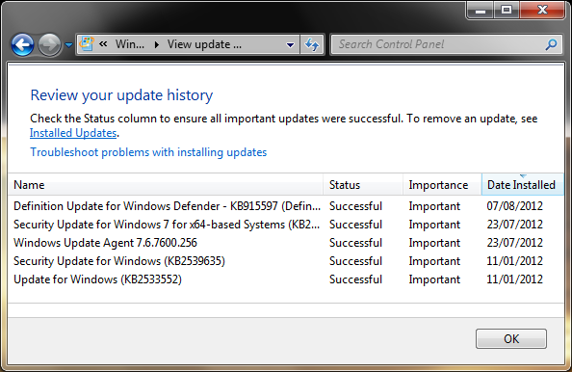Take Windows for example. Windows Update notifies the user when important updates are available, which are then downloaded by a click of a button.

The user can also specify the schedule that Windows follows to install those updates.

Whenever you purchase a computer, it is highly likely that there will be a number of important updates the system needs to make. That’s because it’s probably been sitting in a warehouse for a number of months, and the software is therefore out of date. The same is true if a computer has not been used for a while.

Another example is computer security software such as AVG or McAfee. The user often pays a subscription, and during this period the software will automatically update to receive new virus definitions. In this example, the process is entirely automatic; updates are carried out without any involvement for the user. It is particularly important that software such as anti-viruses update automatically – otherwise it may not be able to detect newer viruses.

### Manual updates

Some software packages require a manual update from the user.   
This is often the case with applications software, where the updates are not essential in terms of maintaining computer security. These updates are likely to be minor improvements or fixing compatibility conflicts with other software.

Most of the time, the user can check for updates via a menu within the software program (as shown on the right), but other programs require the user to manually check their version against the latest file available on their website.



#### LO4: Test yourself – Automatic and manual update facilities

1. Why is it important to keep software up to date?

2. What is the difference between manual and automatic updates?

3. What main issues do software updates address?

# Practice Scenarios

**Scenario 1 (30 marks)**

A business in the USA is developing telematics technology for use in transport.

Car businesses are focusing on producing hands-free and voice-recognition devices that enable a driver to use a phone and access email as well as personalised news, stocks, movie listings and a range of other information while driving. These devices are considered by many to be safer than handheld units.

A system allows a handheld device to be slipped into a docking cradle on the main console of the vehicle so drivers can download email address books, calendars and phone lists.

The system also features a driving simulator that tracks drivers' eye movements while using on-board gadgets. The system uses tactic mobile commerce or ‘m-commerce’ so that when the driver passes a store that catches their eye the store sends the driver a relevant advert. These are called push ads.

**Questions**

**1** (a) Suggest three disadvantages of using a voice-recognition device as input. (3)

(b) What are the advantages to a business of using ‘push ads’ through car technology? (2)

(c) What is the main output device used in the car system? (1)

(d) What factors might affect the advancement of this technology? (5)

**2** (a) Explain how you think this technology reaches the car. (4)

(b) What might be the disadvantages of this type of technology transmission? (2)

(c) What is meant by cloud computing? (1)

(d) What are the advantages of this type of technology for an employee who has to travel the country? (3)

(e) What are the disadvantages to the employee? (2)

**3** (a) How can this use of email be used to support an employee? (2)

(b) With regard to driver safety what might the issues be? (5)

Total: 30 marks

**Scenario 2 (30 marks)**

Japan is a very difficult market to enter for foreign companies. Firms such as Colgate Toothpaste and eBay are simply not present there, and those that are often struggle with their Japanese competitors. In order to be successful, companies are using new technology, such as eye tracking.

To find out what a customer is actually looking at when shopping a technique called ‘eye tracking’ is being used. Shoppers wear a pair of eye glasses that measures and records their eye movements as they go about their shopping. The data collected is processed to provide visual representations of what the shopping population as a whole is actually seeing. Statistics show which products grab and hold the attention of shoppers.

Eye tracking is also being used to improve packaging design, in-store merchandising, and to work out the best way to display products.

Eye-tracking technology is also being used to test the effectiveness of advertising, especially costly TV commercials. For example, skin-response measurements, which function in much the same way as lie-detectors, are being used to supplement the data traditionally obtained via consumer interviews.

Mobile phones are also being used to collect data (although their use is limited). During a set period, each time a shopper comes across a brand that they have been asked to track – on TV, in a store, on a train, on a T-shirt, in a conversation with a friend, even a piece of garbage – they log the touch point, their feelings and any images/movies or comments using their mobile phone. This data is then sent to an online diary for that individual.

**Questions**

**1** (a) The wearing of eye glasses is a customised system for specified needs.

(i) What type of data would be collected from the eye? (1)

(ii) What needs to be done before this data can be processed by a computer? (1)

(iii) What output device is needed for a visual representation? (1)

(iv) Suggest two disadvantages of using this type of method for input. (2)

(v) Suggest two advantages of using this type of method for input. (2)

(b) Describe how eye tracking can be used to:

(i) Improve packaging design (2)

(ii) Assist with in-store merchandising (2)

**2** Eye-tracking technology is also being used to test the effectiveness of advertising, especially costly TV commercials. Skin-response measurements, which function in much the same way as lie-detectors, are being used to supplement the data traditionally obtained via consumer interviews. Users log the touch point, their feelings and any images/movies or comments using a mobile phone.

(a) This is an automatic data capture method. Explain what is meant by automatic data capture. (1)

(b) Suggest three advantages of using this method instead of traditional customer interviews. (3)

(c) Suggest three disadvantages of using this method. (3)

(d) Diary-management software needs to be secure to an individual. Explain a security measure that can be applied to this diary. (2)

(e) Statistics are produced using the data.

(i) What software is most suitable for processing statistics? (1)

(ii) What is the most suitable file format for storing these statistics? (1)

**3** This data is then sent to an online diary for that individual.   
Suggest two ways the online diary can be used to support business working practices. (2)

**4** Mobile phones are being used in advertising as touch parts as an aid to collecting data.  
Explain the moral and legal implications of a company using electronic consumer surveillance. (6)

Total: 30 marks

**Scenario 3 (30 marks)**

A large retail store in Japan has set up a system in their dressing rooms that makes use of RFID tags and VoIP software. Customers use a mobile phone installed in the dressing room to scan the RFID tag on the items of clothing they are trying on and to talk to an employee.

The employee can use their Cisco phone which has a large display to see what similar items are in stock, retrieve the items and then take them to the correct dressing room. The data that is entered into the system is stored for future analysis and helps the business decide on future customer requirements.

The customers also have the option, when the goods are scanned, to enter personal details to enable employees to give future personalised customer care should the customer return to the shop.

**Questions**

**1** (a) What is RFID? (1)

(b) What type of information would the RFID tag contain? (4)

(c) What are the advantages to the company of using RFID? (2)

(d) What software application would store items of stock? (1)

(e) Justify what type of storage system the company would use. (2)

(f) Why would the employee phone have a large display? (1)

**2** (a) How can RFID make the business more efficient? (2)

(b) How does RFID work? (3)

(c) Items stored in a database will probably have validation applied.

(i) What is validation? (1)

(ii) Describe four types of validation check that might be applied to the data held. (4)

**3** (a) How does the use of VoIP support the business’ working practices? (2)

(b) State a health problem that might be associated with this method. (1)

**4** The shop stores personal data on customers for an enhanced service should they wish to return.

(a) What Act must the shop adhere to with regard to this information? (1)

(b) Explain what principles the shop must adhere to in order to comply with this Act. (5)

Total: 30 marks

**Scenario 4 (30 marks)**

Germany has one of the largest shopping stores called Metro Future. Its operation is based on RFID tags. There are RFID kiosks which provide information on what the RFID contains.

There are deactivation stations which deactivate tags as customers leave the stores – it overwrites the number code on the RFID chip with zeros. Goods are placed on a designated surface, the tag is automatically read and the saved number appears on the screen. A touch of a button can then deactivate the tag. The data on the card is not encrypted and operates on an open standard.

Outside the store the tags become inoperable because they are no longer connected to the database.

Due to the size of the store communication is a problem. The database assists the exiting of the merchandise from the central warehouse and the transport of the merchandise to the sales area.

Shoppers can use camera-equipped cell phones to snap pictures of item barcodes and then download the information at the checkout when they are finished shopping. The system then totals all the purchases into one large barcode which you can then scan and pay for.

Loyalty cards collected at the store in Rheinberg, Germany contain hidden RFID remote-tracking chips. They can respond to radio waves and transmit a shopper’s identity to a device between three and five foot away.

Communication is also supported by the use of bulletin boards.

**Questions**

**1** (a) State one disadvantage for the store of using RFID tags. (1)

(b) Multimedia preview stations use DVDs. Why is a DVD used instead of a CD? (2)

(c) All information collected in the store is stored in a database. What are the features of a database which can help the business to be efficient? (2)

(d) RFID kiosks provide information on what the RFID chip contains. What peripherals would this kiosk possibly contain? State their purpose. (4)

**2** (a) What is meant by open source software? (1)

(b) Which of the following is an open file format: doc xls pdf ppt wma (1)

(c) What is encryption? (1)

(d) A camera-equipped cell phone is used instead of scanning the barcodes on the product in order to capture the information. Suggest a reason for this. (1)

(e) With regard to tracking chips, radio waves are used to transmit a shopper’s identity to a device. Suggest the problems with radio wave transmission. (2)

(f) Explain a possible computer system configuration that would enable the system at Metro Future to work. (6)

**3** How might the managers of Metro Future use a bulletin board to assist efficiency? (3)

**4** This system is open to abuse when the customer leaves the store. A person with the appropriate RFID reader can not only hack into the RFID-stored information inside the store but also outside the store.

(a) Suggest some groups of people who might want to do this to harm Metro Future’s management. (3)

(b) Suggest three physical security measures that the management might enforce to minimise these risks. (3)

Total: 30 marks